National Calendar of Training Events

**March– June 2017**

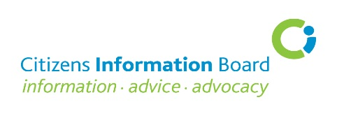

|  |  |  |  |  |  |  |  |
| --- | --- | --- | --- | --- | --- | --- | --- |
| **Date** | | **Course Details** | | **Venue and Time** | |  | |
| **FOR FURTHER INFORMATION AND ONLINE BOOKING CLICK ON THE RELEVANT COURSE** | | | | | | | |
| **8 Mar**  **Level 2** | | [SUSI – Student Universal Support, Ireland](http://learning.ciboard.ie/blocks/cibfindacourse/index.php?courseid=155)  Graham Doyle, Communication and Customer Service Manager, SUSI | | Hilton Dublin Hotel, Kilmainham,  Dublin 8. 10.00am – 1.00pm | |  | |
| **15 Mar**  **Level 2** | | [SUSI – Student Universal Support, Ireland](http://learning.ciboard.ie/blocks/cibfindacourse/index.php?courseid=156)  Graham Doyle, Communication and Customer Service Manager, SUSI | | Sligo Park Hotel, Pearse Road, Sligo  10.00am – 1.00pm | |  | |
| **16 Mar**  **Level 2** | | [SUSI – Student Universal Support, Ireland](http://learning.ciboard.ie/blocks/cibfindacourse/index.php?courseid=157)  Graham Doyle, Communication and Customer Service Manager, SUSI | | Temple Gate Hotel, The Square,  Ennis, Co Clare, 10.00am – 1.00pm | |  | |
| **23 Mar**  **Level 2** | | [SUSI – Student Universal Support, Ireland](http://learning.ciboard.ie/blocks/cibfindacourse/index.php?courseid=158)  Graham Doyle, Communication and Customer Service Manager, SUSI | | Talbot Hotel, Portlaoise Road, Carlow  10.00am – 1.00pm | |  | |
| **27 Mar**  **Level 2** | | [Rent Supplement and Housing Assistance Payments](http://learning.ciboard.ie/blocks/cibfindacourse/index.php?courseid=145)  Community Law and Mediation Service (CLM) | | The Brehon Hotel, Muckross Road, Killarney. 10.00am – 4.30pm | |  | |
| **6th April**  **Level 2** | | [State Pensions](http://learning.ciboard.ie/blocks/cibfindacourse/index.php?courseid=159)  Sheila Hayes, Training Officer, Malahide CIC | | Anner Hotel, Dublin Road, Thurles.  10.00am – 4.30pm. | |  | |
| **7th April** | | [Performance Management Development System (PMDS) for Managers of CIB-funded Services](http://learning.ciboard.ie/blocks/cibfindacourse/index.php?courseid=146)  Isobel Butler, Training Consultant | | Hilton Dublin Hotel, Kilmainham,  Dublin 8. 10.00am – 4.30pm | |  | |
| **12 April**  **Level 2** | | [Maximising Income for Persons Returning to Work](http://learning.ciboard.ie/blocks/cibfindacourse/index.php?courseid=147)  Sheila Hayes, Training Officer, Malahide CIC | | Hilton Dublin Hotel, Kilmainham,  Dublin 8. 10.00am – 4.30pm | |  | |
| **20th April**  **Level 2** | | [The Rights of the Online Consumer](http://learning.ciboard.ie/blocks/cibfindacourse/index.php?courseid=148)  European Consumer Council (ECC) Ireland | | Sligo Park Hotel, Pearse Road, Sligo  10.00am – 4.30pm | |  | |
| **24 April**  **Level 3** | | [Welfare Reform in Northern Ireland incl Cross-Border Implications](http://learning.ciboard.ie/blocks/cibfindacourse/index.php?courseid=172)  Citizens Advice staff - A ‘Border People’ Project initiative | | Virtual Classroom 11.00am -12.30pm  Advance booking required. Click [link](http://learning.ciboard.ie/blocks/cibfindacourse/index.php?courseid=172) | |  | |
| **26 April**  **Level 2** | | [Nursing Home Support Scheme – ‘Fair Deal’](http://learning.ciboard.ie/blocks/cibfindacourse/index.php?courseid=149)  Patricia McDermott, Business Mgr, Nursing Home Section,HSE, Dublin | | CIB Office, 4 The Parade, Kilkenny  10.00am – 1.00pm | |  | |
| **27 April**  **Level 2** | | [Immigrants’ Rights and Entitlements](http://learning.ciboard.ie/blocks/cibfindacourse/index.php?courseid=150)  Immigrant Council of Ireland, (ICI) | | Sligo Park Hotel, Pearse Road, Sligo.  10.00am – 4.30pm | |  | |
| **3 May**  **Level 3** | | [Advanced Means Testing](http://learning.ciboard.ie/blocks/cibfindacourse/index.php?courseid=151)  Ciara Murray, Training Consultant | | Hilton Dublin Hotel, Kilmainham,  Dublin 8. 10.00am – 4.30pm | |  | |
| **10 May**  **Level 2** | | [Personal Taxation](http://learning.ciboard.ie/blocks/cibfindacourse/index.php?courseid=152)  Sheila Hayes, Training Officer, Malahide CIC | | Sligo Park Hotel, Pearse Road, Sligo.  10.00am – 4.30pm | |  | |
| **11 May Level 2** | | [The Rights of the Online Consume](http://learning.ciboard.ie/blocks/cibfindacourse/index.php?courseid=153)r  European Consumer Council (ECC) Ireland | | Killeshin Hotel, Dublin Road, Portlaoise.  10.00am – 4.30pm | |  | |
| **17th May**  **Level 3** | | [Advanced Means Testing](http://learning.ciboard.ie/blocks/cibfindacourse/index.php?courseid=154)  Ciara Murray, Training Consultant | | Absolute Hotel, Sir Harry’s Mall, Limerick. 10.00am – 4.30pm | |  | |
| **18 May**  **Level 2** | | [Recent Developments in Employment Law](http://learning.ciboard.ie/blocks/cibfindacourse/index.php?courseid=161)  Alan Haugh, Barrister-at-Law | | Sligo Park Hotel, Pearse Road, Sligo.  10.00am – 4.30pm | |  | |
| **24 May**  **Level 2** | | [Maximising Income for Persons Returning to Work](http://learning.ciboard.ie/blocks/cibfindacourse/index.php?courseid=162)  Sheila Hayes, Training Officer, Malahide CIC | | Ambassador Hotel, Military Hill, St Luke’s, Cork. 10.00am – 4.30pm | |  | |
| **25 May**  **Level 2** | | [Personal Taxation](http://learning.ciboard.ie/blocks/cibfindacourse/index.php?courseid=163)  Sheila Hayes, Training Officer, Malahide CIC | | Bridge House Hotel, Tullamore, Co Offaly. 10.00am – 4.30pm | |  | |
| **1 June**  **Level 2** | | [State Pensions](http://learning.ciboard.ie/blocks/cibfindacourse/index.php?courseid=164)  Sheila Hayes, Training Officer, Malahide CIC | | Hilton Dublin Hotel, Kilmainham,  Dublin 8. 10.00am – 4.30pm | |  | |
| **7 June**  **Level 2** | | [Immigrants’ Rights and Entitlements](http://learning.ciboard.ie/blocks/cibfindacourse/index.php?courseid=165)  Immigrant Council of Ireland, (ICI) | | Newgrange Hotel, Bridge Street, Navan  Co Meath. 10.00am – 4.30pm | |  | |
| **13 June**  **Level 1** | | [The Administrator in a Citizens Information Service](http://learning.ciboard.ie/blocks/cibfindacourse/index.php?courseid=168)  Cathy O’Donoghue, Anna O’Flanagan, Nicola Walshe, and Ian Coulter, CIB | | St Andrew’s Resource Centre, Pearse Street, Dublin 2. 10.00am – 4.30pm | |  | |
| **14 June**  **Level 3** | | [Employment Law - Advanced](http://learning.ciboard.ie/blocks/cibfindacourse/index.php?courseid=166)  Alan Haugh, Barrister-at-Law | | Ashtown Park Hotel, The Coach Road, Gorey, Co Wexford. 10.00am – 4.30pm | |  | |
| **20 June**  **Level 2** | | [Rent Supplement and Housing Assistance Payments](http://learning.ciboard.ie/blocks/cibfindacourse/index.php?courseid=167)  Community Law and Mediation Service (CLM) | | Hilton Dublin Hotel, Kilmainham, Dublin 8. 10.00am – 4.30pm | |  | |

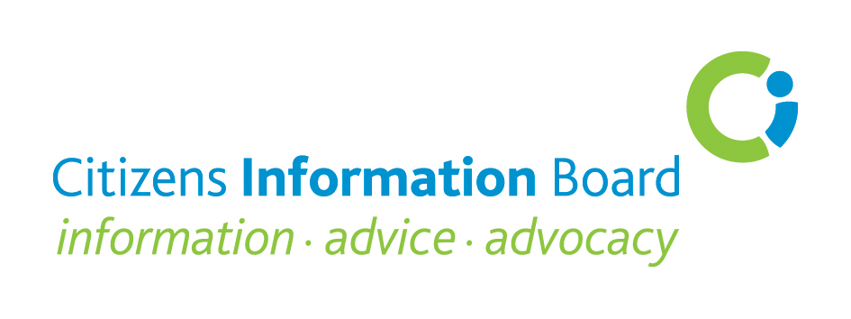

**Course Fees:**

**Citizens Information Service (CIS) Staff/volunteers, MABS staff** **and NAS** **staff**: No fee

**All others:**

Half-day course - **€50** One-day course (including lunch) - **€100**

**Note**: Do not send a cheque to the Citizens Information Board. An invoice is issued after

the event.

Courses at **Level 1** are suited to personnel who have completed their induction training and have some experience of giving information to the public

Courses at **Level 2** are for Information Providers who have completed Year 1 of the Information Advice and Advocacy Programme (IAAP) or its predecessor the Information Providers Programme (IPP) and/or have at least one year’s experience of giving information to the public

Courses at **Level 3** are advanced courses for experienced Information Providers who have a solid knowledge of the course subject matter on offer and wish to enhance and deepen that knowledge

**Enquiries to: Training Executives**

|  |  |
| --- | --- |
| **DUBLIN**  **Anna O’Flanagan**  Citizens Information Board  George’s Quay House, 43 Townsend Street, Dublin 2 Tel: 0761 07 9024  email: [anna.oflanagan@ciboard.ie](mailto:anna.oflanagan@ciboard.ie) | **DUBLIN**  **Cathy O’Donoghue**  Citizens Information Board  4 Adelphi Court, Long Walk,  Dundalk, Co Louth.  Tel 0761 07 5961,  email: [cathy.odonoghue@ciboard.ie](mailto:cathy.odonoghue@ciboard.ie) |
| **NORTH WEST/ WEST**  **Claire Ruddy,**  Citizens Information Board,  Dillon Terrace,  Ballina, Co. Mayo  Tel: 0761 07 5997  Mob 086 2441088  email: [claire.ruddy@ciboard.ie](mailto:claire.ruddy@ciboard.ie) | **MIDLANDS/SOUTH/ SOUTH EAST**  **Ian Coulter**  Citizens Information Board  4 The Parade,  Kilkenny.  Tel: 0761 07 9623  email: [ian.coulter@ciboard.ie](mailto:ian.coulter@ciboard.ie) |