National Calendar of Training Events

**September – December 2017**

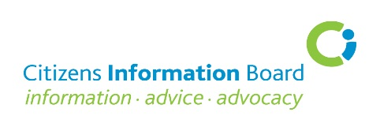

|  |  |  |  |
| --- | --- | --- | --- |
| **Date** | | **Course Details** | **Venue and Time** |
| **13 Sept**  **Level 2** | [**Family Law**](https://learning.ciboard.ie/blocks/cibfindacourse/index.php?courseid=206)  Anne O’Carroll, Cascade Training Consultancy | | Brehon Hotel, Muckross Road,  Killarney, Co. Kerry. 10.00am – 4.30pm |
| **14 Sept**  **Level 2** | [**State Pensions**](https://learning.ciboard.ie/blocks/cibfindacourse/index.php?courseid=207)  Sheila Hayes, Training Officer, Malahide CIC | | Bridge House Hotel, Tullamore,  Co. Offaly. 10am – 4.30pm |
| **21Sept**  **Level 2** | [**State Pensions**](https://learning.ciboard.ie/blocks/cibfindacourse/index.php?courseid=208)  Sheila Hayes, Training Officer, Malahide CIC | | Sligo Park Hotel, Pearse Road, Sligo  10.00am – 4.30pm |
| **27 Sept**  **Level 2** | [**Immigrants’ Rights and Entitlements**](https://learning.ciboard.ie/blocks/cibfindacourse/index.php?courseid=210)  Immigrant Council of Ireland (ICI) | | Hilton Dublin Hotel, Kilmainham,  Dublin 8. 10.00am – 4.30pm |
| **17 Oct**  **Level 3** | [**Advanced Means Testing**](https://learning.ciboard.ie/blocks/cibfindacourse/index.php?courseid=211)  Ciara Murray, Training Consultant | | Radisson Blu Hotel, Athlone,  Co. Westmeath. 10.00am – 4.30pm |
| **18 Oct**  **Level 2** | [**Recent Developments in Employment Law**](https://learning.ciboard.ie/blocks/cibfindacourse/index.php?courseid=212)  Alan Haugh, Barrister-at-Law | | Hilton Dublin Hotel, Kilmainham,  Dublin 8. 10.00am – 4.30pm |
| **19 Oct**  **Level 2** | [**Personal Taxation**](https://learning.ciboard.ie/blocks/cibfindacourse/index.php?courseid=213)  Sheila Hayes, Training Officer, Malahide CIC | | Hilton Dublin Hotel, Kilmainham,  Dublin 8. 10.00am – 4.30pm |
| **24 Oct**  **Level 2** | [**Rent Supplement and Housing Assistance Payments**](https://learning.ciboard.ie/blocks/cibfindacourse/index.php?courseid=214)  Community Law and Mediation Service (CLM) | | Killeshin Hotel, Dublin Road, Portlaoise,  Co. Laois. 10.00am – 4.30pm |
| **25 Oct**  **Level 2** | [**Immigrants’ Rights and Entitlements**](https://learning.ciboard.ie/blocks/cibfindacourse/index.php?courseid=215)  Immigrant Council of Ireland (ICI) | | Anner Hotel, Dublin Road, Thurles,  Co. Tipperary. 10.00am – 4.30pm |
| **1 Nov**  **Level 2** | [**Maximising Income for Persons Returning to Work**](https://learning.ciboard.ie/blocks/cibfindacourse/index.php?courseid=216)  Sheila Hayes, Training Officer, Malahide CIC | | Sligo Park Hotel, Pearse Road, Sligo  10.00am – 4.30pm |
| **7 Nov**  **Level 3** | [**Employment Law – Advanced**](https://learning.ciboard.ie/blocks/cibfindacourse/index.php?courseid=220)  Alan Haugh, Barrister-at-Law | | Absolute Hotel, Sir Harry’s Mall,  Limerick. 10.00am – 4.30pm |
| **8 Nov**  **Level 3** | [**Advanced Means Testing**](https://learning.ciboard.ie/blocks/cibfindacourse/index.php?courseid=217)  Ciara Murray, Training Consultant | | Sligo Park Hotel, Pearse Road, Sligo  10.00am – 4.30pm |
| **8 Nov**  **Level 2** | [**Maximising Income for Persons Returning to Work**](https://learning.ciboard.ie/blocks/cibfindacourse/index.php?courseid=218)  Sheila Hayes, Training Officer, Malahide CIC | | Glenview Hotel, Glen of the Downs,  Delgany, Wicklow. 10.00am – 4.30pm |
| **9 Nov**  **Level 2** | [**Family Law**](https://learning.ciboard.ie/blocks/cibfindacourse/index.php?courseid=219)  Anne O’Carroll, Cascade Training Consultancy | | Sligo Park Hotel, Pearse Road, Sligo  10.00am – 4.30pm |
| **16 Nov**  **Level 2** | [**Personal Taxation**](https://learning.ciboard.ie/blocks/cibfindacourse/index.php?courseid=221)  Sheila Hayes, Training Officer, Malahide CIC | | Ambassador Hotel, Military Hill.  St. Luke’s, Cork. 10.00am – 4.30pm |
| **21 Nov**  **Level 2** | [**The Rights of the Online Consumer**](https://learning.ciboard.ie/blocks/cibfindacourse/index.php?courseid=222)  European Consumer Council (ECC) Ireland | | Hilton Dublin Hotel, Kilmainham,  Dublin 8. 10.00am – 4.30pm |
| **28 Nov**  **Level 2** | [**Rent Supplement and Housing Assistance Payments**](https://learning.ciboard.ie/blocks/cibfindacourse/index.php?courseid=223)  Community Law and Mediation Service (CLM) | | Sligo Park Hotel, Pearse Road, Sligo  10.00am – 4.30pm |
| **30 Nov**  **Level 2** | [**The Rights of the Online Consumer**](https://learning.ciboard.ie/blocks/cibfindacourse/index.php?courseid=224)  European Consumer Council (ECC) Ireland | | Ambassador Hotel, Military Hill.  St. Luke’s, Cork. 10.00am – 4.30pm |

**Course Fees:**

Citizens Information Service (CIS) Staff/volunteers, MABS staff and NAS staff: **No fee**

All others:Half-day course - **€50** One-day course (including lunch) - **€100**

**Note**:

Do not send a cheque to the Citizens Information Board. An invoice is issued after

the event.

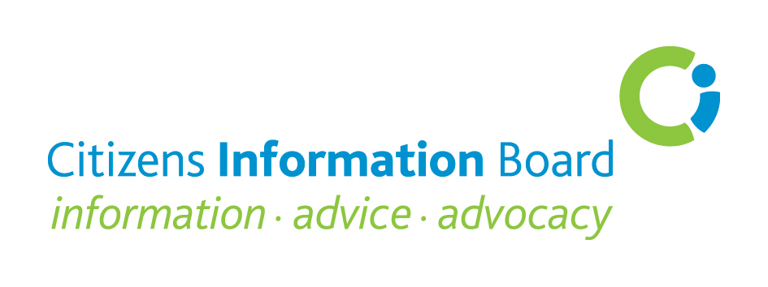

Courses at **Level 1** are suited to personnel who have completed a comprehensive induction training programme and have some experience of giving information to the public.

Courses at **Level 2** are for Information Providers who have completed the Essential Training for Information Providers (ETIP) Programme or its predecessor the Information Providers Programme (IPP) and/or have at least one year’s experience of operating independently in a CIS providing information, advice and assistance to the public.

Courses at **Level 3** are advanced courses for experienced Information Providers who have Year 1 of the Information, Advice and Advocacy Practice (IAAP) or Information, Provision and Advocacy Practice (IPAP) and for those who have a solid knowledge of the course subject matter on offer and wish to enhance and deepen that knowledge.

**Enquiries to:**

|  |
| --- |
| **Josephine Glennon, Training Executive,**  Citizens Information Board  George’s Quay House, 43 Townsend Street, Dublin 2  Tel: 0761 07 9017  email: [josephine.glennon@ciboard.ie](mailto:josephine.glennon@ciboard.ie) |
| **Ann Marie Byrne, Training Administrator,**  Citizens Information Board,  C/O Co. Offaly CIS, Level 1, The Bridge Centre, Tullamore, Co. Offaly  Tel: 0761 07 6295  email: [annmarie.byrne@ciboard.ie](mailto:annmarie.byrne@ciboard.ie) |