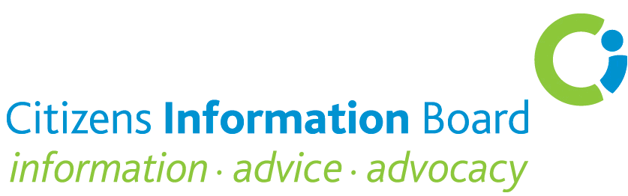

Re: Freedom of Information Model Publication Scheme

Citizens Information Board Submission September 2015

The Citizens Information Board (CIB) welcomes the Freedom of Information Model Publication Scheme. The Scheme can enhance significantly the implementation of the long-standing commitment on the part of public services in Ireland to provide information that is clear, timely and accurate, is available at all points of contact and meets the requirements of people with specific needs.

While it is anticipated that the publication scheme may lead to a reduction in FOI requests and a related reduction in related workloads and while this is an important consideration, it is equally and, perhaps, more important, that the scheme enhances access to public service information by citizens.

Without good quality, accessible information, it is not possible for citizens to vindicate their rights or to make valuable contributions to the policy-making processes. The provision of seamless information continues to present significant challenges in the current fragmented benefit- by-benefit department/ agency approach to services.
One of the functions of CIB service delivery partners is to bridge the gap between citizens and the wide range and complexity of Government services. Frequently, the assistance that people require relates to accessing relevant information from public services. Clearly, the functioning of these services can be become more effective through easily accessible information from public bodies and the Model Publication Scheme is very welcome in this regard.

Availability of information is obviously an essential component in accessing the wide and disparate range of Government services and myriad of social provisions with sometimes complex sets of rules and procedures.

There is a need, the CIB believes, for public bodies to clearly acknowledge on an ongoing basis that, while much web-based information is very accessible, there are some people who have difficulties in understanding the way digital information is organised and experience difficulty in accessing it. While this situation is fast changing, there continue to be many people for whom communications technology does not feel at all friendly or accessible and are effectively excluded from this information source.

While there is reference in the Scheme Guidance to the need to provide links to various sections of an organisation’s website, ideally there would be provision for links to other organisations’ websites, particularly in the case of Government Departments where there are areas of overlap, e.g., in the case of people with disabilities.

The CIB notes as important the following points referenced in the Document:
- Publishing as much information as possible in keeping with transparency and public accountability
- The need to ensure that information is as comprehensible as possible

- The presentation of information using a common template

- The need for information to be updated on a regular basis –particularly important because of the ever-evolving public service delivery environment
- The desirability of going beyond the minimum information requirement outlined in the Scheme
- The need for a different scheme for smaller FOI bodies
The CIB suggests that, in finalising the Model Publication Scheme, consideration should be given to the following points.

- Ensuring that the need for people to seek information under the FOI legislation is kept to a minimum
- Ensuring that the publication scheme is fully accessible
- The need for a Plain English approach in the language used
- Provisions for people who communicate differently, e.g. people with a visual impairment and the Deaf community
- Specific provisions for people who are unable to easily access basic information on-line

Citizens Information Services (CISs), the Citizens Information Phone Service (CIPS), Money Advice and Budgeting Services (MABS), the National Advocacy Service for People with Disabilities (NAS) and the Sign Language Interpreting Service (SLIS). These services deal with in excess of 800,000 people annually.

