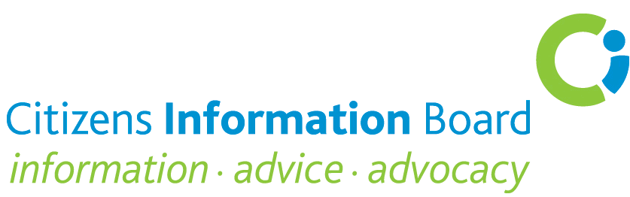
National Entrepreneurship Policy Statement Consultation
Citizens Information Board Submission
The Citizens Information Board (CIB) welcomes the decision to put in place a National Entrepreneurship Policy Statement and the related consultation process in which the Board is pleased to participate. In 2012, the CIB published a report, Hard Times for the Self-employed: Citizens Information and MABS Experience, which highlighted a range of issues affecting self-employment in Ireland. The CIB also provides an information website for the self- employed www.selfemployedsupports.ie
The CIB notes that the most recent QNHS figures (Quarter 1 2013) show that 303,500 people are self-employed (71% with no employees). While the overall figure has increased from 290,900 in the first quarter of 2012, there was an annual decrease of 3,300 in the number of self-employed with paid employees. This decrease in the numbers of self-employed people with paid employees which has been ongoing for a number of years presents a significant challenge to the Government’s emphasis on micro and small businesses as a core element in its Action Plan for Jobs 2013. It is also noted that there has been a small reduction in the number of unemployed people seeking work as self-employed.
The CIB acknowledges the National Entrepreneurship Policy Statement as a necessary and important initiative at this juncture in order to ensure a business environment conducive to entrepreneurship and enterprise creation. There are a number of inter-related dimensions:
- Policies aimed at actively promoting the option of self-employment and stimulating development through the implementation of support programmes and incentives
- A macro/regulatory framework conducive to entrepreneurship and responsible risk-taking
- Social policies (including health, social insurance and pensions) that underpin the longer-term well-being of the self-employed and their families; and
- Provision for realistic access to start-up and business development finance and to information and related supports
Since establishing a micro business frequently involves considerable risk, with survival chances that are difficult to assess, it is important that as much protection as possible is available through structural policies (including national long-term economic strategy and planning), through the regulatory system and through the social protection system. These are key considerations for the National Entrepreneurship Policy Statement.

The social welfare and taxation systems must be such as to enable people to pursue employment and income generating opportunities in the knowledge that they will have fair and equitable social insurance protection in the event of sickness/disability or unemployment. It is the view of the CIB that the question of social insurance for the self-employed should be considered in the broader policy context of how entrepreneurship and related self-employment is to be promoted in the current economic climate. The possible negative impact of perceived potential financial risks for those setting up micro businesses and the related need for optimum protection by the social insurance system must be a key consideration.

The Hard Times for the Self-employed Report raised a fundamental question as to whether or not a self-employed person should enjoy the same protection against social risks and labour related risks as employees do and suggested that in the current economic and labour market there are strong arguments for both the self-employed and employees enjoying the same protection. A key factor in this regard is that it is almost certain that frequent transitions into and out of self-employment will become a growing feature in the employment histories of the labour force.

Ireland is one of the few EU countries that do not have any insurance-based provisions for unemployment, illness/disability or occupational injury in respect of the self-employed. Therefore, any extension of coverage would bring the Irish social insurance system more in line with provisions in other EU states. This applies particularly in relation to work related and occupational injury where a number of EU countries provide cover as part of the general insurance system or as part of a voluntary scheme. The Hard Times for the Self-employed Report highlights the need to explore further the risks associated with being self-employed so as to provide some additional options for insurance-based contributions to cater for contingencies of unemployment, illness or disability. The report also notes that if social insurance is to be extended to the self- employed to a greater extent than currently i.e. not just in relation to pensions – this should be reflected in the level of contribution rates into the social insurance system.

The CIB believes that the promotion of entrepreneurship as a key component in moving out of the current recession will require looking at and addressing the issue of insurance cover in the context of the economic risk for the self-employed. How to achieve this presents a significant challenge because of the perception that a self-employed person can influence his/her situation of unemployment more than an employee can and the related difficulty in ensuring equity and accountability. The Board notes that the question of broader insurance cover for self-employed persons is currently being considered by the Advisory Group on Tax and Social Welfare which was established by the Minister for Social Protection. The cost to the exchequer of extending social insurance cover to the self-employed and the potential significant cost for self-employed persons of any such extension are key factors to be considered.

At a more general level, it is widely acknowledged that education and training can promote an entrepreneurial culture. Education and training (including lifelong education and training) thus need to have a stronger focus on entrepreneurship and creativity than is currently the case.

The recent establishment of the 31 Local Enterprise Offices is a very welcome development as is the related central support role of Enterprise Ireland.
The integration of the local development dimension into the promotion of entrepreneurship is regarded by the CIB as a key factor. However, it is unlikely that this will happen to the degree hoped for by Government without a significant stimulative input into local communities. This should be a key consideration in the National Enterprise Policy Statement. Also, it may be unrealistic to expect that local authorities can carry out this developmental role within current resources.

Given the significant financial difficulties and in some instances indebtedness being experienced by small businesses, consideration should be given to the establishment of a separate support unit for small businesses in debt along the lines of the Business Debtline in the UK. Such a provision could involve MABS and the recently established network of Local Enterprise Offices.
Given the range of agencies engaging with self-employed people and supporting entrepreneurial activity and the need for co-ordinated measures, a proactive approach to information dissemination should be adopted on all aspects of enterprise (start-up, grants and other related supports) and on social welfare support for self-employed people. While there is much relevant information available on the Department of Jobs, Enterprise and Innovation website and on the CIB website www.selfemployedsupports.ie and while it is likely that the new Local Enterprise Offices will have an enhanced information provision role, the CIB believes that there would be much merit in developing a targeted and collaborative information initiative involving the Department of Jobs, Enterprise and Innovation, the Citizens Information Board, the Department of Social Protection, the Revenue Commissioners and self-employed representative organisations. Provision for such an initiative should be included in the National Enterprise Policy Statement.
As a final point, the CIB believes that there is a need for a stronger evaluation component to programmes and support policies targeted at promoting entrepreneurship. Such evaluations should take into account the broader business environment at national level, the developmental potential at local level and, very importantly, the factors that impact positively or negatively on entrepreneurial activity at both national and local levels.

http://www.citizensinformationboard.ie/publications/social/downloads/Hard_Times_for_Selfemployed_2012.pdf. Citizens Information Services supported by the CIB dealt with over 700,000 callers and almost a million queries from members of the public in 2012. MABS services have a caseload of over 26,000 indebted clients.
The 2010 Actuarial Review of the Social Insurance Fund found that the self -employed achieve better value for money compared to the employed.

