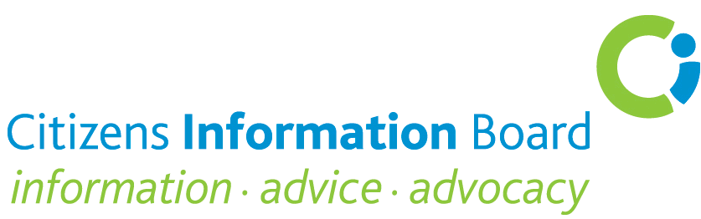

Consultation on Charities Regulatory Authority
Citizens Information Board Submission

What, in your opinion (or that of your organisation) should be the top three priority areas of activity for the Charities Regulatory Authority in its first three years of existence, and why?

The Citizens Information Board (CIB) acknowledges that, due to current budgetary constraints, the work of the Charities Regulatory Authority will have to be developed and consolidated on a phased basis. Notwithstanding this requirement, there is a need to put in place a three-year strategy if the implementation of the Charities Act 2009 is to have meaningful resonance for the public generally and for charities. Such a strategy should include the following provisions:

- The dissemination of clear information about the requirements of the Charities Act 2009, particularly in relation to registration, financial accountability and fundraising activities
- The proactive dissemination of information about the role, status, responsibilities and compliance requirements of the Charities Regulatory Authority
- The establishment of the Charities Regulatory Authority as a reliable repository of information on charities – compliance requirements, standards and best practice
- The development of an interactive website which sets out principles, standards and processes
- The development of best practice standards and related guidelines for fundraising (including a mechanism for participating organisations to certify that their fundraising procedures are in accordance with the quality standards)
- The establishment of a transparent and efficient complaints process
- Protocols for collaboration with other relevant agencies, including, in particular, the Companies Registration Office, the HSE and HIQA and any other regulatory authorities as well as voluntary sector umbrella bodies such as The Wheel and Fundraising Ireland.

Consultation Question 2
What are the main reasons you would consult the Register of Charities?
There would be three main reasons why the CIB and its service delivery partners (Citizens Information Services (CIS), Money Advice and Budgeting Services (MABS) and the National Advocacy Service (NAS)) would consult the Register of Charities:

- To validate information provided by charities in respect of grant applications

- To identify the potential at local or regional levels for collaboration with other NGOs in developing responses to citizens’ information, advice and advocacy needs identified
- To explore the extent of volunteering generally and at local and national levels

Consultation Question 3
How often do you think you would consult the published statutory Register of Charities?
This is difficult to estimate but could be up to 10-12 times a year based on the likely use by both the CIB itself and our service delivery partners.

Consultation Question 4
What, if any, information additional to that required under Section 39 (7) of the Charities Act do you think should be included in the published Register of Charities?
Consideration should be given to including the following additional information in the published Register of Charities:

- The specific population group/category being catered for
- Whether or not State funding is received

Consultation Question 5
Do you agree with the proposed fee structure?

Yes – it seems balanced and reasonable.

Consultation Question 6
If you answered "no" to question 5 above, what alternative fee structure to the one proposed above would you prefer to see put in place?
N/A

Consultation Question 7
Do you agree with the proposed income thresholds for financial accounting and reporting by charities?

Some consideration might be given to raising the lower threshold and introducing additional thresholds and requirements over €100,000 in line with fee structure.
Consultation Question 8
Are there alternative income thresholds to those proposed above that you would prefer to see put in place?

Increase lower income threshold to €15,000.

Consultation Question 9
What information would you like to see included in the annual financial reports provided by registered charities to the Charities Regulatory Authority?
Sources of core/ancillary funding and percentage breakdown by:

- State grant-aid
- Fundraising
- Donations/bequests

Consultation Question 10
What information would you like to see included in the annual activity reports provided by registered charities to the Charities Regulatory Authority?
It would be important to establish:

- Whether or not the Charity is a direct provider of services
and, if so,
- What the primary target group is, e.g., children, older persons, people with disabilities, migrants

Consultation Question 11
What type of report and accounts filing system would you be most likely to use? (For charitable organisations only):
Consultation Question 12
If there are any other comments or suggestions you would like to make about any of the issues dealt with in this consultation document, please add them here
Balancing the Cost with Other Factors
While the costs of setting up and running the Charities Regulatory Authority and the Register of Charities are relatively significant in the current economic climate, it is important that these costs are counterbalanced with four important factors:
- The long-standing acknowledgement for greater regulation of the charities sector to ensure transparency and best practice in both fundraising and how monies are spent
- The need to ensure that scarce statutory resources (in terms of grant-aid) are used to optimum effect to ensure a fair response to the needs of all citizens
- The need for members of the public to have absolute confidence that any money given to charities (sometimes at a cost to themselves) is properly accounted for
- The need for the growing number of people seeking assistance from charities to be able to do so knowing that these charities are above reproach in their management, administration and fundraising activities.
Monitoring and Implementing the Registration Requirements
A crucial question will be how the registration requirements and related compliance are to be monitored. In the longer-term and, as resources permit, there will be a need to put in place detailed sets of standards for the charities sector and to set up an inspectorate to monitor their implementation. The model used by HIQA offers useful guidance in this regard. In the short to medium-term the emphasis should be on creating a climate where both the public and charities individually and collectively subscribe to the need for transparency and compliance with the legislation and work towards eliminating any practices that may fall short in this regard. This should be done in a manner which acknowledges that many organisations are already fully compliant with the charities legislative requirements.
Other Considerations
  - There should be a standardised and easy–to-use reporting template.
  - There is a need to co-ordinate and minimise duplication in reporting requirements with other regulators and funders
  - It is essential that any information held on the Register of Charities should be readily available to the public, including web-based and printed media and should be easily retrieved
  - The Charities Regulatory Authority should publish a comprehensive and timely annual report.
  - As part of its role, the Charities Regulatory Authority should draw up Standardised Guidelines for all Trustees (Directors) of Charities which sets out their role, responsibilities and duties irrespective of what form of legal structure or governing instrument is used (whether the charity is an unincorporated association, a trust or a company limited by guarantee).
  - Such Guidelines should include specific reference to the duty of care owed by trustees or directors of a charity individually and collectively

