DUBLIN SOUTH CITIZENS INFORMATION SERVICE

Senior Information Officer (x2)

(Full-time, Permanent Position)

Applicant Information Pack

June 2022

1 x Dublin South 12 & 24 (Tallaght & Crumlin)

1 x Dublin South West (Ballyfermot, Clondalkin & Lucan)

Senior Information Officer – Contents

CIS Service Offer - Page 3

CIS Locations - Page 4

Job Description - Page 5

Person Specifications - Page 7

Required Competencies - Page 8

Terms and Conditions - Page 10

How to Apply - Page 11

Citizens Information Service - Service Offer

Citizens Information Services (CISs) provide free, impartial and confidential information, advice and advocacy services to the public. Each Citizens Information Service covers a geographical area within their region, facilitating both rural and urban areas, delivering a service through a network of Citizen Information Centres (CICs).

Information and Advice

Our Information Officers assist people with queries in relation to a broad spectrum of public and social services, including social welfare entitlements, income tax calculations, housing supports and access to health services. Our staff receive regular training and social policy updates to ensure that the information and advice that we provide is up-to-date and relevant for CIS service-users.
Social Policy

Our staff also engage in social policy reporting, highlighting issues that affect CIS clients in accessing public services, which in turn feeds into the work of the Citizens Information Board in the development of policy papers and recommendations to government. Through this process, CIS Information Officers capture social policy issues in real-time, facilitating the development of responsive and evidence-based policy reporting.

Advocacy

If a person presents with a query or problem that we are not able to assist with through our drop-in information/advice service, Information Officers can provide further support through our advocacy service. This can mean a once-off engagement, such as assisting someone to write a letter or make a phone call, or a complex and longer-term process such as preparing people for, or representing them at, a Social Welfare Appeals Office or Workplace Relations Commission hearing.

The range and level of advocacy support provided by CISs has continued to develop and expand year on year, with significant outcomes achieved for people around the country in the areas including employment, equality, housing and social welfare. All Information Officers are supported by a regional Advocacy Support Worker who provides expert advice, coaching and mentoring in this key aspect of our work.

Applicants

If you are interested in working within a dynamic, face-to-face information service environment, engaging in representative advocacy casework, and leading a team of Information Providers to deliver these services to the general public, we welcome your application for the permanent position of Senior Information Officer with our service.

Citizens Information Services – Locations

Each Citizens Information Regional Company covers a geographical region, facilitating both rural and urban areas, delivering a service through a network of Citizen Information Centres.

The 8 regional CIS companies cover the following areas: North Dublin, Dublin South, North Connacht & Ulster, North Leinster, North Munster, South Connacht, South Leinster and South Munster, as illustrated in the map below. Each CIS Region is subdivided into a number of CIS Service Areas which in turn each contain a number of Citizens Information Centres.

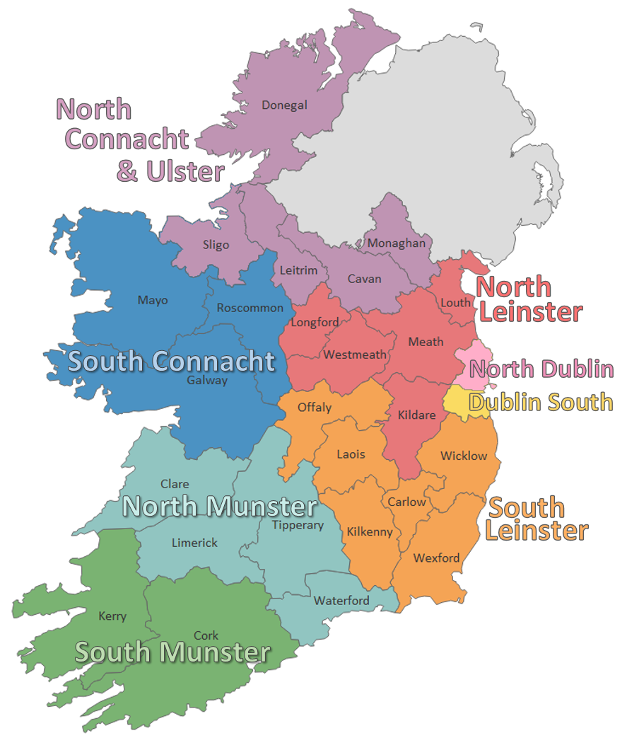
Senior Information Officer - Job Description

Purpose of the job:
The Senior Information Officer role is comprised of two central functions, with working hours divided equally between the following responsibilities:
- To deliver information, advice and advocacy at a high level to members of the public in a designated service area.
- To coach, mentor and support Information Officers to ensure that all customer-service quality objectives and standards are met.

Reporting to:
The Development Manager

Main Duties and Responsibilities:

Information, Advice and Advocacy
- The direct delivery of face to face information, advice and advocacy services to the public at a complex level, in the core areas of Citizens Information Service provision, including social welfare, employment, housing, consumer, immigration and disability rights, in line with the Citizens Information Board guidelines for the provision of Citizens Information Services (CIS).
- Maintain comprehensive and up-to-date knowledge of relevant legislative and policy developments in the core areas of Citizens Information Service provision.
- Maintain an active advocacy caseload and provide complex advocacy to CIS service-users, including representation at fora including the Social Welfare Appeals Office, Workplace Relations Commission, and Residential Tenancies Board.
- Operation of query management, advocacy case management and data collection/statistical analysis systems.

Coaching and Mentoring
- Coach and mentor staff in the development of their information, advice and advocacy skills, ensuring that all members are working to achieve service objectives and delivery targets and the delivery of a high quality professional service.
- Provide regular updates and briefings to Information Providers on legislative, policy and administrative changes relevant to the provision of information and advocacy.
- Assist Information Providers to identify, record and report on social policy issues and provide regular social policy updates and briefings to the Information Provider team.
- Provide information in a variety of formats to outside agencies and community organisations as and when required and to support the Information Providers in developing these skills.
- Provide regular reports to the Development Manager and Information Providers team.
- Support the Development Manager to allocate the service’s advocacy caseload efficiently, including external referral and engagement with the Advocacy Support Worker (ASW) as required.

Service Delivery
- Contribute to the development and implementation of policies and procedures as required.
- Comply with GDPR policies and procedures and all other legislative and policy requirements.
- Engage with CIB and other stakeholders as required.
- Lead and/or participate in projects as required by the Development Manager.
- This list is not exhaustive but serves to reflect the nature of the responsibilities included in the role.
- Given the nature of the organisation and the need to respond to customers’ needs on an ongoing basis, the role is subject to change over time.

Quality
- Contribute to and implement any quality control measures required for information, advice and advocacy ensuring a common quality standard is applied across the relevant service. This will involve direct observation and review of Information Providers.
- Provide regular reports to the Development Manager regarding quality control issues.
Identify training requirements within the Information Providers team and support the implementation of ongoing training programmes.
- Support the Development Manager to conduct regular advocacy case reviews to ensure professional standards are met in adherence with ASW programme best practice.

Senior Information Officer - Person Specifications

Essential Educational Qualifications and Attainments
A relevant recognised qualification at degree level or a combination of a relevant recognised diploma qualification & equivalent professional experience

Desirable Educational Qualifications and Attainments
Training/qualifications in one or more of the following areas:
- Coaching and Mentoring Quality Assurance
- Advocacy
- GDPR
- Social Policy

Essential Knowledge, Skills and Experience
- At least 3 years’ full-time (or equivalent part-time) experience in an information, advice and advocacy giving role within, or comparable with, the Citizens Information Services.
- Excellent oral and written advocacy skills in areas such as:
  - social welfare,
  - employment
  - housing
  - consumer affairs
  - immigration

- Commitment to high-quality customer service and continuous service quality evaluation and improvement.
- Strong capacity to support an information team in the context of a fast-paced working environment, and ability to be flexible in approach.
- Sound analytical, critical thinking and decision-making skills
- Ability to analyse statistical information, and to prepare and present operational reports.
- Strong IT skills.
- Capacity to liaise at a high level with other public services or NGOs other Citizens Information channels, with the Department of Employment Affairs and Social Protection, and with other service providers.
- The highest standards of honesty and integrity.
- The ability to deal with change and challenging situations.

Desirable Knowledge, Skills and Experience
- Coaching and mentoring experience in a front-line service delivery setting
- Experience working in the community / voluntary sector
- Use of information systems and resources

Senior Information Officer – Required Competencies

Competency | Definition
Research and Analysis | Conducts research across a wide variety of information sources.  Evaluates complex information accurately to reach well-informed judgments.  Demonstrates an excellent knowledge of information sources relevant to social services and civil rights.
Expert Knowledge | Excellent working knowledge of the Irish public service systems (e.g. social welfare, employment, housing, consumer affairs, immigration, health and income tax systems).  Knowledge of interactions between these various systems and how they may affect CIS service users.  Identifies and reports on social policy issues effectively.
Delivery of information, advice and advocacy services | Communicates complex information and advice clearly and understandably to clients.  Analyses information and situations accurately, evaluates it comprehensively and comes to well-balanced judgements.  Ability to represent, negotiate and communicate on a client’s behalf through formal processes.  Experienced in written and oral advocacy on behalf of individuals in accessing relevant public and private services, including formal representation at hearings.
Organisation, Administration and IT | High level of competency in the use of relevant IT software, using systems to organise and prioritise workload effectively, and consistently meet deadlines.  Ability to use query management, data collection/statistical analysis systems efficiently.  Knowledge of Data Protection / GDPR requirements in relation to the protection of personal data.

Competency | Definition
Communication | Ability to impart information knowledgeably and clearly, ensuring that information provided is clearly understood.  Communicates clearly, concisely and confidently both verbally and in writing.  Makes an evidential and persuasive case.  Negotiates complex issues in a structured, assertive but respectful manner.
Customer Service | Demonstrates a customer oriented approach to all work, and committed to meeting the expectations and requirements of service-users.  Capacity to engage with service-users from diverse backgrounds, demonstrating knowledge and sensitivity to issues including disability, diversity, equality and cultural difference.  Is responsive to customer needs, reacting quickly and delivering a quality services to meet those needs appropriately.
Team Working and Team Leadership | Builds positive working relationships that engender trust.  Deals constructively with conflict.  Ability to work collaboratively with both team and management in the development of the service.  Leads a team effectively.
Coaching and Mentoring | Ability to support an Information Provider team, being flexible in approach and adaptive to the needs of staff based on individual levels of experience and competency.  Is sensitive, structured and supportive in facilitating quality and case reviews.  Shows a balance of empathy and insight in feedback and framing development.
Senior Information Officer – Required Competencies (cont.)

Senior Information Officer – Terms and Conditions

This is a permanent, full-time position, subject to satisfactory completion of a six-month probationary period. The period of probation may be extended at the discretion of the Development Manager/Regional Manager. The successful candidate will be available to work 35 hours per week, (Monday to Friday). There may be a requirement to work evenings from time-to-time.

Salary: Scale range of €35,831; €37,411; €39,548; €41,093; €42,663; €44,080; €45,498; LSI 1 €46,916; LSI 2 €48,333 (pro rata).

Incremental Credit: The Citizens Information Service operates an incremental credit process for appointments higher than point one of the salary scale. This process is applicable to new entrants into the CIS. Incremental credit criteria, based on the competencies for the role, are assessed against employment history as laid out in the application form. A request for incremental credit from a successful candidate must be made within the first 3 months of employment.

Pension: A company pension scheme is in place, and membership is obligatory upon commencement.. Employee contribution; 5% of salary, Employer contribution; 7% of salary. Please note the Citizens Information Service has established a normal retirement age in line with the state pension age (currently 66).

Annual Leave: Calculated on a pro rata basis for

Annual Leave: Calculated on a pro rata basis for part year service as follows:

- 23 days
- 24 days (upon completion of 2 years’ service)
- 25 days (upon completion of 5 years’ service)

Full terms and conditions are contained in a Staff Handbook, which is issued with and forms part of the Employee Contract at CIS.

Senior Information Officer – How to Apply

- A relevant application form can be accessed at www.citizensinformationboard.ie
- Applicants must possess all required competencies for the role and will be shortlisted solely on the basis of information provided in their completed application form.
- Curriculum Vitae (CVs), late, incomplete or hand-written applications will not be considered.
- Closing Date: 5pm Monday, 27th June 2022
- Please email application form to: DublinSouthRecruit@citinfo.ie
- If you require any reasonable accommodation to your application due to your circumstances (e.g. disability), please contact the above email address and we will try and facilitate you where reasonably practicable.

- Successful applicants will be required to complete a writing skills assessment on the day of interview.

- A panel of qualified candidates may be formed from which temporary and permanent, part-time and full-time Senior Information Officer posts which arise in a specified period, up to a maximum of 12 months, will be filled. Posts will be located in the Dublin South CIS region.

- For information on how your personal data will be used as part of this process please refer to our Data Protection Notice for Job Applicants, available at the following link:
http://www.citizensinformationboard.ie/en/data_protection/cis.html

Citizens Information Services are equal opportunities employers.

