CITIZENS INFORMATION SERVICE

Administrator

(Part time, Temporary Position located in Cork City)

Applicant Information Pack

Administrator - Contents

Citizens Information Service Offer- Page 3

CIS Locations - Page 4

Administrator Role - Job Description - Page 5

Person Specification - Page 6

Required Competencies – Page 7

Terms and Conditions - Page 8

How to Apply - Page 9

Citizens Information Service - Service Offer

Citizens Information Services (CISs) provide free, impartial and confidential information, advice and advocacy services to the public. Each Citizens Information Service covers a geographical area within their region, facilitating both rural and urban areas, delivering a service through a network of Citizen Information Centres (CICs).

Information and Advice

Our Information Officers assist people with queries in relation to a broad spectrum of public and social services, including social welfare entitlements, income tax calculations, housing supports and access to health services. Our staff receive regular training and social policy updates to ensure that the information and advice that we provide is up-to-date and relevant for CIS service-users.
Social Policy

Our staff also engage in social policy reporting, highlighting issues that affect our clients in accessing public services, which in turn feeds into the work of the Citizens Information Board in the development of policy papers and recommendations to government. Through this process, CIS Information Officers capture social policy issues in real-time, facilitating the development of responsive and evidence-based policy reporting.

Advocacy

When required, Information Officers can provide further support through our advocacy service. This can mean assisting someone to write a letter or make a phone call, or a more complex and longer-term process such as preparing people for, or representing them at, a Social Welfare Appeals Office or Workplace Relations Commission hearing. All Information Officers are supported by a regional Advocacy Support Worker who provides expert advice, coaching and mentoring in this key aspect of our work.

The range and level of advocacy support provided by CISs has continued to develop and expand year on year, with significant outcomes achieved for people around the country in the areas including employment, equality, housing and social welfare.

Citizens Information Services – Locations

Each Citizens Information Regional Company covers a geographical region, facilitating both rural and urban areas, delivering a service through a network of Citizen Information Centres.

The 8 regional CIS companies cover the following areas: North Dublin, Dublin South, North Connacht & Ulster, North Leinster, North Munster, South Connacht, South Leinster and South Munster, as illustrated in the map below. Each CIS Region is subdivided into a number of CIS Service Areas which in turn each contain a number of Citizens Information Centres.

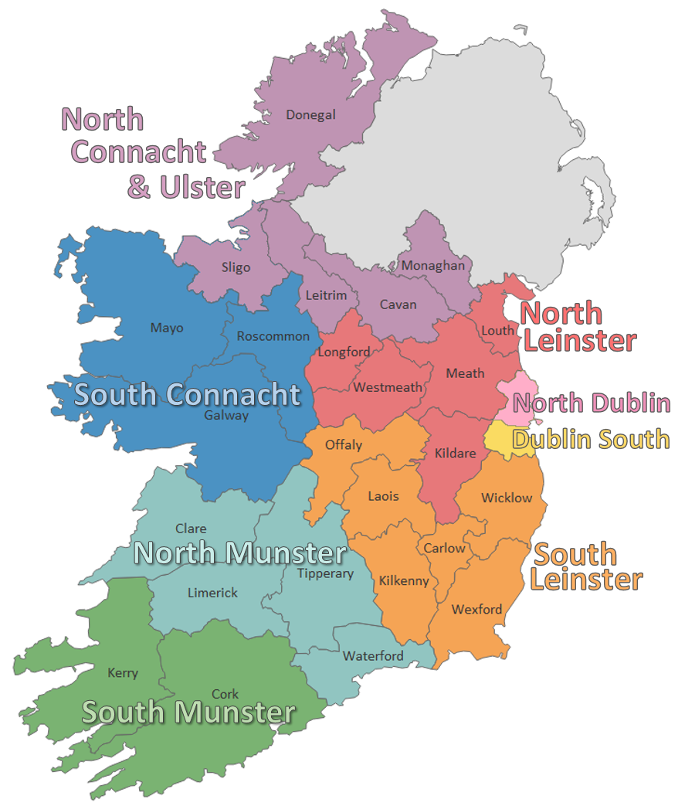

Administrator - Job Description

Purpose of the job
The Administrator will provide clerical support to the Development Manager in the running of the information service. Key tasks for the post include responsibility for secretarial, administration, and financial records processing for the assigned office in the region.

Reporting to
The Development Manager

Overview
The Administrator will be responsible for the daily administration of the centre, carrying out a range of clerical and administrative duties, as assigned by the Development Manager.

Main Duties and Responsibilities
- Daily administration of the centre.
- Respond to queries from members of the public in person, by phone and by email.
- Carry out a range of clerical and administrative duties, as assigned by the Development Manager to include; typing, letter writing, report writing, etc.
- Maintain records and files adhering to best practice guidelines around data protection and GDPR.
- Assist in the collection and preparation of data for the centre’s monthly, quarterly and annual returns.
- Assist in the preparation of financial transactions and reports for the centre e.g. payroll, PAYE/PRSI returns.
- Organise events and meetings for the centre, taking minutes where required.
- Ensure the centre has adequate stocks of stationery supplies, publications, information leaflets, application forms etc.
- Operate switchboard and cover reception when required.
- Liaise with the staff of the centre, volunteers, contractors and creditors and debtors when required.
- Undertake training and development to maintain and improve performance and assist in identifying self-training and support needs.

Administrator - Person Specification

Essential Educational Qualifications and Attainments
- Good general level of education - Leaving Certificate or equivalent
- Some certification in Microsoft Office or equivalent

Desirable Educational Qualifications and Attainments
- A recognised qualification in financial administration

Essential Knowledge, Skills & Experience
- Experience of working in an administrative role in a busy office environment
- Customer service experience, both face to face, over the phone and by email
- Excellent written, communication and numeracy skills
- Good working knowledge of Microsoft Office
- Experience in data processing and filing using ICT systems
- Knowledge or experience in financial and accounts data processing
- Ability to work on own initiative or as part of a team
- Self-motivated, flexible and reliable
- Good organisational skills
- Maintenance of the highest standards of honesty and integrity

Desirable Knowledge, Skills & Experience
- Some knowledge of the Citizens Information Services and the work they do.
- Some knowledge of / experience in one or more of the following areas: -
  - Payroll
  - PAYE / PRSI returns
  - Preparing bank transactions
  - Using IT financial software packages

Administrator – Required Competencies

Competency | Definition
Information processing and records management | Records and retrieves information electronically and in hard copy.  Uses and supports data collection and case management systems.  Observes confidentiality in the administration of personal and financial data.
Communication | Fluent in written and verbal English.  Writes clearly and concisely producing accurate emails, letters and documents.  Keeps clear records that are easy for others to understand.
Customer Service | Demonstrates a commitment to quality customer service and displays a client centred approach to their work.  Engages with others in a respectful and understanding manner. Shows cross cultural sensitivity.
Office Accounts | Shows attention to detail in the processing of information.  Processes numerical information efficiently.
Team Working | Works effectively as part of a team.  Demonstrates an openness to support, supervision and feedback and adapts approach in a constructive manner

Administrator – Terms and Conditions

This is a temporary position, subject to satisfactory completion of a six-month probationary period. The period of probation may be extended at the discretion of the Development Manager.

The successful candidate will be available to work 35 hours per week (full time) / 17.5 hours per week (part time). There may be a requirement to work evenings from time-to-time.

Salary: Scale range of €24,407, €25,554, €26,697, €27,845, €28,991, €30,136, €31,279, €32,420, €33,567, (max), €34,710 (LSI1), €35,858 (LSI2). Pro rata for part-time staff.

Incremental Credit: The Citizens Information Service operates an incremental credit process for appointments higher than point one of the salary scale. This process is applicable to new entrants into the CIS. Incremental credit criteria, based on the competencies for the role, are assessed against employment history as laid out in the application form. A request for incremental credit from a successful candidate must be made within the first 3 months of employment. The decision on whether or not to award incremental credit is made by the board and is subject to the availability of funding.

Pension: A company pension scheme is in place, and membership is obligatory upon commencement. Employee contribution; 5% of salary, Employer contribution; 7% of salary. Please note the Citizens Information Service has established a normal retirement age in line with the state pension age (currently 66).

Annual Leave: Calculated on a pro rata basis for part year service as follows:

23 days
24 days after 2 years’ service
25 days after 5 years’ service

Full terms and conditions are contained in a Staff Handbook, which is issued with and forms part of the Employee Contract.

Administrator – How to Apply

- A relevant application form can be accessed at www.citizensinformationboard.ie
- Applicants must possess all required competencies for the role and will be shortlisted solely on the basis of information provided in their completed application form.
- Curriculum Vitae (CVs), late, incomplete or hand-written applications will not be considered.
- Closing date: Date 12 noon on Thursday 1st September 2022
- Please email application form to: recruitsouthmunster@citinfo.ie
- If you require any reasonable accommodation to your application due to your circumstances (e.g. disability), please contact the above email address and we will try and facilitate you where reasonably practicable.
- Successful applicants will be required to complete a writing skills assessment on the day of interview.

- A panel of qualified candidates may be formed from which temporary, part-time Administrator posts which arise in a specified period, up to a maximum of 12 months, will be filled. Posts will be located in the CIS region applied for.

- For information on how your personal data will be used as part of this process please refer to our Data Protection Notice for Job Applicants, available at the following link:
http://www.citizensinformationboard.ie/en/data_protection/cis.html

Citizens Information Services are equal opportunities employers.

