CITIZENS INFORMATION SERVICE

Information Officer

1 x Part-Time, Permanent Position located in Fermoy

SMCIS is seeking to develop a panel for other permanent part-time vacancies which may arise across its region over the next 12 months.

Applicant Information Pack

August 2022

Information Officer – Contents

CIS Service Offer - Page 3

CIS Locations - Page 4

Job Description - Page 5

Person Specifications - Page 6

Required Competencies - Page 7

Terms and Conditions - Page 9

How to Apply - Page 10

Citizens Information Service - Service Offer

Citizens Information Services (CISs) provide free, impartial and confidential information, advice and advocacy services to the public. Each Citizens Information Service covers a geographical area within their region, facilitating both rural and urban areas, delivering a service through a network of Citizen Information Centres (CICs).

Information and Advice

Our Information Officers assist people with queries in relation to a broad spectrum of public and social services, including social welfare entitlements, income tax calculations, housing supports and access to health services. Our staff receive regular training and social policy updates to ensure that the information and advice that we provide is up-to-date and relevant for CIS service-users.
Social Policy

Our staff also engage in social policy reporting, highlighting issues that affect our clients in accessing public services, which in turn feeds into the work of the Citizens Information Board in the development of policy papers and recommendations to government. Through this process, CIS Information Officers capture social policy issues in real-time, facilitating the development of responsive and evidence-based policy reporting.

Advocacy

If a person presents with a query or problem that we are not able to assist with through our drop-in information/advice service, Information Officers can provide further support through our advocacy service. This can mean a once-off engagement, such as assisting someone to write a letter or make a phone call, or a complex and longer-term process such as preparing people for, or representing them at, a Social Welfare Appeals Office or Workplace Relations Commission hearing.

The range and level of advocacy support provided by CISs has continued to develop and expand year on year, with significant outcomes achieved for people around the country in the areas including employment, equality, housing and social welfare. All Information Officers are supported by a regional Advocacy Support Worker who provides expert advice, coaching and mentoring in this key aspect of our work.

Applicants

If you are interested in working within a dynamic, face-to-face information service environment, engaging with people from diverse backgrounds and life-experiences, while contributing to social policy development, and engaging in advocacy casework to support those most in need of overcoming barriers to accessing their rights, we welcome your application for the permanent part-time position of Information Officer with our service.

Citizens Information Services – Locations

Each Citizens Information Regional Company covers a geographical region, facilitating both rural and urban areas, delivering a service through a network of Citizen Information Centres.

The 8 regional CIS companies cover the following areas: North Dublin, Dublin South, North Connacht & Ulster, North Leinster, North Munster, South Connacht, South Leinster and South Munster, as illustrated in the map below. Each CIS Region is subdivided into a number of CIS Service Areas which in turn each contain a number of Citizens Information Centres.

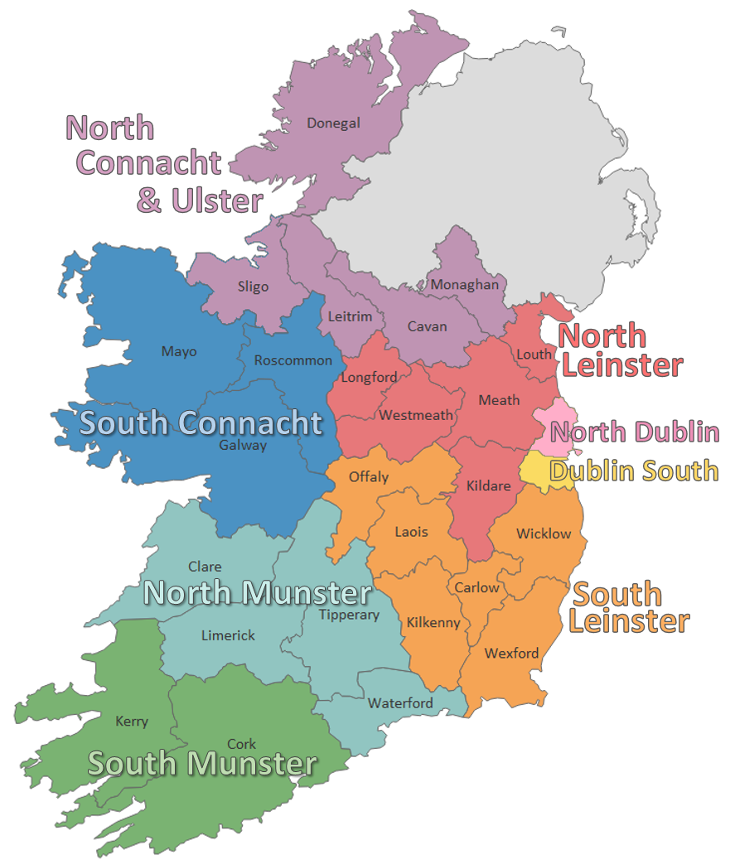

Information Officer - Job Description

Responsible to:
Reporting to the Development Manager on a day-to-day basis.

Purpose of the job:
The provision of information, advice and advocacy services to members of the public and assisting the Development Manager in the work of the information service.

Main Duties:

- The direct delivery of information, advice and advocacy services as determined by the Board of Directors and in line with the Citizens Information Board guidelines for the provision of Citizens Information Services
- The delivery of outreach services through Citizens Information Services and other outlets as required
- Follow up work arising from information and/or advocacy sessions with clients.
- Assisting the Development Manager in the development of innovative processes for the provision of quality information to clients in various formats using the Citizens Information Board Citizens Information website www.citizensinformation.ie as an information tool, supplemented by other relevant information sources.
- To co-operate with other service providers in the area and more generally, both statutory and voluntary, in the development of information and advocacy provision and on joint-initiatives from time to time.
- Operation of query management, advocacy case management and data collection/statistical analysis systems
- Operation of systems for monitoring and evaluation of the service
- Undertaking publicity and promotional initiatives appropriate to the development of the service.
- Assisting in any research and/or social policy initiatives appropriate to the development of the service.
- Identifying and feeding back to the Citizens Information Board, issues that have social policy implications
- Representing the CIS at conferences etc. as decided by the Board or Development Manager.
- Such duties (including administrative duties) as may be assigned from time to time by the Development Manager

Information Officer - Person Specifications

Minimum Education Qualifications and Attainments
- Educated to Leaving Certificate standard, or equivalent, with a minimum of one year’s experience of working in an information, advice, or advocacy setting.
or
- Less formal academic qualifications with a minimum of three years’ experience of working in an information, advice, or advocacy.

Essential Knowledge and Experience

- An understanding of the issues around the provision of, and access to information, advice and advocacy services.
- Working knowledge and understanding of how the social welfare, health and income tax systems operate in general and a working knowledge of at least one of the following subject areas: employment, housing, immigration, consumer rights, education
- Excellent organisational, administrative and IT skills.

Desirable Skills, Abilities and Experience

- Demonstrated ability to absorb, analyse and evaluate information from a variety of sources.
- Strong communication skills, both orally and in writing
- Have previous experience in the information or voluntary sector
- Proven ability to represent, negotiate and communicate on a client’s behalf
- Ability to work on own initiatives and as a member of a team, working effectively within the support and supervision structures operated by the CIS
- Ability to interpret and implement organisational policy.

Successful Candidate will be
- Committed to the provision of free, confidential, impartial, local and independent information, advice and advocacy services
- Have an understanding and knowledge of the range of information, advice and advocacy services provided by the Citizens Information Services supported by the Citizens Information Board and knowledge of volunteering, with reference in particular to the distinctive characteristics of an organisation which provides a service to the public through the agency of trained volunteer personnel
- Be open to work unsocial hours as may be required from time to time and willing to attend evening and occasional week-ends. Time Off In Lieu (TOIL) arrangements apply in all such circumstances.

Information Officer – Required Competencies

Competency | Definition
Research | Conducts research across a wide variety of information sources.  Skilled in accessing, eliciting, exploring and categorising relevant information in a timely manner.  Manages personal / sensitive information in a manner compliant with Data Protection regulations.
Expert Knowledge | Familiar with Irish social welfare, employment law, housing and other relevant public service systems in Ireland.  Knowledgeable of at least one of the following systems: social welfare, employment, housing, consumer affairs, health, education, immigration, equality, disability rights.  Understands how interactions between these various systems may affect the general public in accessing services.
Delivery of information, advice and advocacy services | Identifies and understands issues of concern for the client.  Analyses information and situations accurately, evaluates options comprehensively and comes to well-informed and balanced conclusions.  Communicates complex information and advice clearly and understandably to clients.  Represents, negotiates and communicates on a client’s behalf through formal and informal processes.
ICT and Information Management | Organises, uses, records and manages information in a careful methodical and regulatory compliant manner.  Plans and organises activities and schedules in a structured, efficient and timely manner using IT systems as appropriate.  Uses email, file storage systems, data collection and case management systems effectively.

Communication | Imparts information knowledgeably and clearly, ensuring that their message is understood  Communicates clearly, concisely and confidently both verbally and in writing.  Advocates and negotiates in a structured and constructive manner to achieve beneficial solutions.
Customer Service | Demonstrates a customer oriented approach to all work. Committed to meeting the expectations and requirements of service-users.  Engages with people from diverse backgrounds, demonstrating knowledge and sensitivity to issues of disability, diversity, equality and cultural difference.  Engages positively with performance and service review processes relevant to quality of customer service delivery.
Team Working | Builds strong working relationships characterised by respect, trust and cooperation. Deals constructively with conflict.  Demonstrates an openness and receptivity to support, supervision and feedback and adapts approach accordingly.

Information Officer – Required Competencies (cont.)

Information Officer – Terms and Conditions

This is a permanent part time position, subject to satisfactory completion of a six-month probationary period. The period of probation may be extended at the discretion of the Development Manager/Regional Manager. The successful candidate will be available to work 35 hours per week (full time) / 17.5 hours per week (part time). There may be a requirement to work evenings from time-to-time.

Full Time Salary: Scale range of €29,821, €31,996, €34,193, €35,828, €37,411, €39,544, €41,096, €42,659 (max), €44,080 (LSI1), €45,498 (LSI2). Salaries pro-rata for part-time work.

Incremental Credit: The Citizens Information Service operates an incremental credit process for appointments higher than point one of the salary scale. This process is applicable to new entrants into the CIS. Incremental credit criteria, based on the competencies for the role, are assessed against employment history as laid out in the application form. A request for incremental credit from a successful candidate must be made within the first 3 months of employment. The decision on whether or not to award an incremental credit is made by the board and is subject to the availability of funding.

Pension: A company pension scheme is in place, and membership is obligatory upon commencement. Employee contribution; 5% of salary, Employer contribution; 7% of salary. Please note the Citizens Information Service has established a normal retirement age in line with the state pension age (currently 66).

Annual Leave: Calculated on a pro rata basis for part year service as follows:

- 23 days
- 24 days (upon completion of 2 years’ service)
- 25 days (upon completion of 5 years’ service)

Full terms and conditions are contained in a Staff Handbook, which is issued with and forms part of the Employee Contract at CIS.

Information Officer – How to Apply

- A relevant application form can be accessed at www.citizensinformationboard.ie
- Applicants must possess all required competencies for the role and will be shortlisted solely on the basis of information provided in their completed application form.
- Curriculum Vitae (CVs), late, incomplete or hand-written applications will not be considered.
- Please contact recruitsouthmunster@citinfo.ie if you have any special requirements in relation to completing the application form.

- Closing date: 12 noon on Thursday 1st September 2022

- Please email application form to: recruitsouthmunster@citinfo.ie

- Successful applicants will be required to complete a writing skills assessment on the day of interview.

- A panel of qualified candidates may be formed from which permanent, part-time Information Officer Posts which arise in a specified period, up to a maximum of 12 months, will be filled. Posts will be located in the CIS service area applied for. You may apply for several or all locations. Locations are identified in the application form.

- For information on how your personal data will be used as part of this process please refer to our Data Protection Notice for Job Applicants, available at the following link: http://www.citizensinformationboard.ie/en/data_protection/cis.html

Citizens Information Services are equal opportunities employers.

