CITIZENS INFORMATION SERVICE

Development Manager

(Full-time Permanent position)

Applicant Information Pack

Development Manager – Contents

CIS Service Offer - Page 3

CIS Locations - Page 4

Job Description - Page 5

Person Specifications - Page 8

Required Competencies - Page 10 & 11

Terms and Conditions – Page 12

How to Apply - Page 13

Citizens Information Service - Service Offer

Citizens Information Services (CISs) provide free, impartial and confidential information, advice and advocacy services to the public. Each Citizens Information Service covers a geographical area within their region, facilitating both rural and urban areas, delivering a service through a network of Citizen Information Centres (CICs).

Information and Advice

Our Information Officers assist people with queries in relation to a broad spectrum of public and social services, including social welfare entitlements, income tax calculations, housing supports and access to health services. Our staff receive regular training and social policy updates to ensure that the information and advice that we provide is up-to-date and relevant for CIS service-users.
Social Policy

Our staff also engage in social policy reporting, highlighting issues that affect our clients in accessing public services, which in turn feeds into the work of the Citizens Information Board in the development of policy papers and recommendations to government. Through this process, CIS Information Officers capture social policy issues in real-time, facilitating the development of responsive and evidence-based policy reporting.

Advocacy

When required, Information Officers can provide further support through our advocacy service. This can mean assisting someone to write a letter or make a phone call, or a more complex and longer-term process such as preparing people for, or representing them at, a Social Welfare Appeals Office or Workplace Relations Commission hearing. All Information Officers are supported by a regional Advocacy Support Worker who provides expert advice, coaching and mentoring in this key aspect of our work.

The range and level of advocacy support provided by CISs has continued to develop and expand year on year, with significant outcomes achieved for people around the country in the areas including employment, equality, housing and social welfare.

Citizens Information Services – Locations

Each Citizens Information Regional Company covers a geographical region, facilitating both rural and urban areas, delivering a service through a network of Citizen Information Centres.

The 8 regional CIS companies cover the following areas: North Dublin, Dublin South, North Connacht & Ulster, North Leinster, North Munster, South Connacht, South Leinster and South Munster, as illustrated in the map below. Each CIS Region is subdivided into a number of CIS Service Areas which in turn each contain a number of Citizens Information Centres.

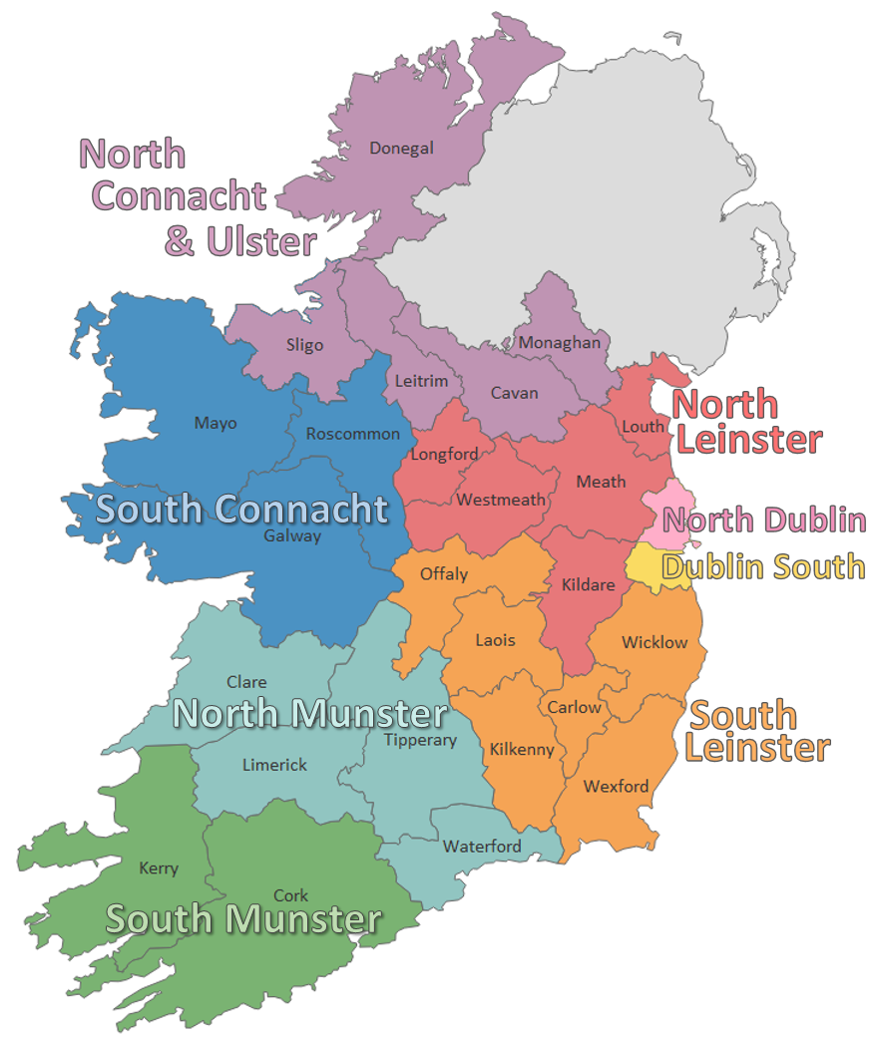

Development Manager - Job Description

Responsible to:
The Regional Manager of North Dublin Citizens Information Service (CIS)

Purpose of the job:
- To be responsible for the management and development of service delivery within a specified service-area of the North Dublin Citizens Information Service region, and to contribute to the development, leadership and management of the service as part of the Regional Management Team.

Main Duties:
- Be responsible for the development and delivery of service of the assigned service-area, in line with the company’s strategy, action plan and the Citizens Information Board guidelines for the provision of Citizens Information Services.

- To contribute to the development and implementation of a regional strategy for the provision of quality information, advice, and advocacy services.

Management of Service Delivery
- Manage and develop the provision of information and advice services within the service area.
- Manage and develop the provision of advocacy services within the service-area, with the support and assistance of the Advocacy Support Worker and other approved advocacy supports.
- Identify, manage and promote outreach services and other information-related activities within the service-area, in line with the company’s regional strategy and available resources.

Leadership, Management and Team Development
- Lead, manage and motivate a team of paid and unpaid staff (including volunteers and scheme workers, in conjunction with relevant stakeholders) within the service-area in the effective provision of Information, advice and advocacy services.
- Responsible for identifying ongoing training, development and support needs of staff and address these through local, regional, and national training provisions.
- Actively participate within the regional performance management development system (PMDS) process, ensuring that this process is implemented with all paid staff reporting directly to this position.

Quality Control
- Responsible for the implementation of approved quality-control mechanisms to ensure accuracy and consistency of information and advice provision within the service-area.
- Manage and actively monitor the accurate and timely electronic recording of CIS outputs in line with relevant data recording and case management requirements.
- Contribute to the development and operation of systems for monitoring and evaluating outputs of the CIS region within relevant guidelines, and responsibility for managing the implementation of same within the service-area.
- Ensure compliance with data protection legislation and instill good practice among staff in this regard.
- Highlight issues of concern regarding accessibility to CIS services to the Regional Manager.
- Implement referral pathways both inter and cross-regionally to support client access to appropriate level of service provision.
- Support the coordination of referrals to other services and collaborate with other CIB funded services to support clients.

Administration
- Responsible for the effective management of recording and reporting on information, advice, and advocacy activity within the service-area, including the reporting of social policy issues to the Citizens Information Board.
- Responsible for planning, managing and delivering timely and relevant service reports as required.
- Manage service-area / project budgets as assigned by the Regional Manager from time to time.
- Ensure the implementation of the provided financial system within national and regional financial control and budgetary guidelines.
- Attend meetings and provide annual and other reports / submissions as required.

HR
- Ensure compliance with employment legislation and with agreed HR policies and procedures as provided for within the CIS Staff Handbook.
- Maintain service-area HR files and provide HR reports to the Regional Manager.
- Responsible for managing / supporting the recruitment of paid staff as agreed with the Regional Manager and in line with the company’s regional staffing strategy and CIS HR policies and procedures.

Promoting CIS
- Undertake publicity and research initiatives appropriate to the development of the service at the service-area level within CIB Financial Controls and procurement requirements.
- Contribute to and support regional publicity and research initiatives in conjunction with the Regional Management Team.
- Contribute to and support the development and implementation of a regional communications strategy in conjunction with Regional Management Team.
- Contribute to and support the development and implementation of an outreach strategy in conjunction with Regional Management Team.
- Develop, manage and consolidate effective relationships with key stakeholders both locally and regionally, and undertake outreach and other service related activities, as required.

Contributing to CIS Regional and National Development
- Work collaboratively as part of the Regional Management Team to implement the organisation’s Strategic Plan.
- Contribute towards the development of policy and strategy at a national level in conjunction with the CIS Regional Manager.
- Support the Regional Manager on projects, innovations and developments within the organisation, and in the strategic planning for the service.

Facilities Management
- Oversee the effective maintenance and management of CIC premises in the specified service-area.
- Act as key liaison for all ICT issues and developments in the specified service-area in liaison with CIB IT Support and the Regional Manager.
- Where appropriate, identify new premises opportunities, relocation or renovation projects and make recommendations to the Regional Manager for progressing such initiatives.
- Project manage approved projects in consultation with the Regional Manager and other approved project partners.

Health and Safety
- Ensure the regional health and safety plan is implemented within the service-area and follow all reporting guidelines regarding incidents/accidents at work.
- Participate in health and safety teams and initiatives within the region.

Other Responsibilities
- The Development Manager will also be required to perform other duties, appropriate to the role, from time to time.
- Be open to working unsocial hours as may be required from time to time and willingness to attend evening and occasional weekend events. (Time Off In Lieu arrangements apply in all such circumstances).
PERSON SPECIFICATION
Essential Qualifications
- A relevant 3rd level qualification (social sciences, humanities, law, HR, management - Level 8 on the NFQ framework)

AND

- Minimum of 3 years’ experience in a managerial role in a similar environment.

OR

- Less formal qualifications will be considered if candidates can demonstrate significant managerial experience (minimum 5 years) in a similar work environment.

Desirable Qualifications

• Management qualification
• Information/Advice/Advocacy qualification

Essential knowledge and experience

- Significant experience in managing and/or delivering a complex service as relevant to this role (minimum 3 years).
- Operational experience in managing and delivering change in a complex environment, as relevant to this role.
- Experience of managing a team.
- Extensive knowledge of rights, entitlements and social policy issues relevant to CIS.
- Excellent interpersonal and communication skills.
- Excellent standard of written English, report writing and evaluation skills.
- Excellent IT and service data/case management software skills.
- Experience of and commitment to capacity building among staff and organisations.
- Strong leadership skills with a track record of innovation and implementing organisational improvements.
- High degree of personal integrity.
- Knowledge of and experience in coaching, mentoring and/or staff training.
- Ability to monitor and evaluate quality of service outputs and outcomes.
- Experience of managing and motivating others and supervising professional practice.
- A deep understanding of the needs of people with disabilities, of marginalised groups, persons in vulnerable situations, and the barriers experienced in accessing services.
- Excellent judgment, with flexibility and problem solving abilities.
- Experience in oral presentations and public speaking.
- Knowledge and understanding of Data Protection obligations.

Desirable skills, abilities and experience

• Knowledge of community development.
• Experience in project management.
• Experience in delivering information, advice and advocacy, including representative advocacy services to the public and collaborative practice with other agencies.
• Flexibility of approach and innovative thinking towards project/strategic work.
• Networking skills.
• Experience in facilities management.
• Experience in health and safety management.

Core and special aptitudes, and skills

• Effective interpersonal and communication skills.
• Ability to work as part of a management structure.
• Management and delivery of results.
• Leadership and management skills.
• Analysis and decision-making skills.
• Administration/ organisational and IT skills.

Development Manager – Required Competencies

Competency | Definition
Management, Leadership & Team Development | - Ability to lead a team, encouraging, inspiring and supporting others to deliver on organisational strategies, action plans and day-to-day service requirements  - Provides clear information and guidance as to what is required of the team  - Leads the team by example, coaching and supporting individuals as required  - Works with the team to facilitate high performance and addressing any performance issues if they arise  - Places high importance on staff development/training and maximising skills and capacity of the team  - Is flexible and willing to adapt, positively contributes to organisational strategies, plans and the implementation of change
Client Focus & Quality | - Understands who the client is and is willing and able to deliver high quality services  - Proven ability to meet the needs and, potentially exceed, the expectations of all clients  - Constantly strives to find new ways to increase client satisfaction  - Demonstrates a clear commitment to organisation quality customer service, standards, strategies, policies and initiatives  - Applies appropriate systems or processes to enable quality checking of all activities and outputs
Effective Communication | - Ability to effectively communicate, both verbally and in writing, with individuals and groups  - Ensures there is an effective flow of information between the team and regional management  - Establishes quick and easy rapport with staff, colleagues and external stakeholders  - Treats others with diplomacy, tact, courtesy and respect even in challenging circumstances  - Collaborates and supports colleagues and regional management to achieve organisational goals
Management & Delivery of Results | - Ability to focus efforts and energy on successfully achieving standards of excellence in delivery of goals and objectives.  - Thinks ahead, identifies opportunities and independently takes action to influence events where appropriate  - Is accountable for meeting objectives to the required standard  - Ability to monitor own performance as well as that of a team and takes initiative to improve performance  - Takes responsibility and is accountable for the delivery of service in their given area  - Structures and organises their own and their team’s work effectively
Competency | Definition
Analysis, Reporting & Decision Making | - Effectively deals with a wide range of information sources, investigating all relevant issues.  - Uses numerical data skilfully or in evaluating the service  - Finds new ways of reporting information and improving on existing reporting processes both quantitatively and qualitatively  - Identifies gaps or anomalies in service provision or policy and prepares reports and submissions  - Draws accurate conclusions & makes balanced and fair recommendations backed up with evidence
Specialist knowledge &  Self-Development | - Has high levels of expertise and knowledge of rights, entitlements and social policy issues relevant to CIS  - Knowledge and understanding of Data Protection obligations  - Knowledge of the legislative, policy and regulatory framework Develops and maintains skills and expertise to perform the role effectively e.g. relevant software and IT systems, organisational policies and procedures and relevant legislation, policy and regulatory framework  - Constantly learns from experience and takes the initiative to develop new skills and expertise through research, learning and training

Development Manager – Terms and Conditions

This is a permanent, full-time position, subject to satisfactory completion of a six-month probationary period. The period of probation may be extended at the discretion of the Regional Manager. The successful candidate will be available to work 35 hours per week, (Monday to Friday). There may be a requirement to work evenings from time-to-time.

Salary: Scale range of €44,078; €45,496; €46,915; €48,334; €48,869; €50,314; €53,022; €54,252; €55,744; €57,076 (max), €57,879 (LSI1), €58,682 (LSI2 (pro rata for part time staff).

Incremental Credit: The Citizens Information Service operates an incremental credit process for appointments higher than point one of the salary scale. This process is applicable to new entrants into the CIS. Incremental credit criteria, based on the competencies for the role, are assessed against employment history as laid out in the application form. A request for incremental credit from a successful candidate must be made within the first 3 months of employment.

Pension: A company pension scheme is in place, and membership is obligatory upon commencement. Employee contribution; Minimum 5% of salary, Employer contribution; 7% of salary. Please note the Citizens Information Service has established a normal retirement age in line with the state pension age (currently 66).

Annual Leave: Calculated on a pro rata basis for part year service as follows:

- 25 days
- 26 days (upon completion of 2 years’ service)
- 27 days (upon completion of 5 years’ service)

Full terms and conditions are contained in a Staff Handbook, which is issued with and forms part of the Employee Contract at CIS.

Development Manager – How to Apply

- A relevant application form can be accessed from the vacancy section of www.citizensinformationboard.ie
- Applicants must possess all required competencies for the role and will be shortlisted solely on the basis of information provided in their completed application form.
- Curriculum Vitae (CVs), late, incomplete or hand-written applications will not be considered.
- Closing date: 1pm. February 4th 2022
- Please email application form to: Teresa Gil, Teresa.gill@citinfo.ie clearly marking the email “Application for Development Manager”

- If you require any reasonable accommodation with your application due to your circumstances (e.g. disability), please contact the above email address and we will try and facilitate you where reasonably practicable.

- A panel of qualified candidates may be formed from which temporary and permanent, part-time and full-time Development Manager posts which arise in a specified period, up to a maximum of 12 months, will be filled. Posts will be located in the CIS region applied for.

- For information on how your personal data will be used as part of this process please refer to our Data Protection Notice for Job Applicants, available at the following link: http://www.citizensinformationboard.ie/en/data_protection/cis.html

Citizens Information Services are equal opportunities employers

