CITIZENS
INFORMATION
SERVICES

Q3 Statistical
Report 2025

Citizens Information Services (CIS) Caller and Query

Statistical Summary

July to September (Q3) 2025
Table of Contents
Section 1: Overview and Trends 3
Section 2: Caller Summary 4
Section 3: Query Summary …………………………………………………………………………………………………………………..…8
Section 4: Social Welfare ……………………………………………………………………………………………………………..……….10
Section 5: Housing ………………………………………………………………………………………………………………………..………13
Section 6: Health 15
Section 7: Other Query Areas …………………………………………………………………………………………………………………..18
Appendix: Breakdown of Top Three Query Areas by Level Three Categories ……………………………..…………..20

Section 1: Overview and Trends
This statistical summary of CIS callers (clients) and queries focuses on Quarter 3 2025, compared with the same period in 2024. Quarterly query trends are not necessarily indicative of trends for a full year’s dataset – changes and patterns reflected from quarter to quarter may balance out over a year – but provide a useful means of comparison.
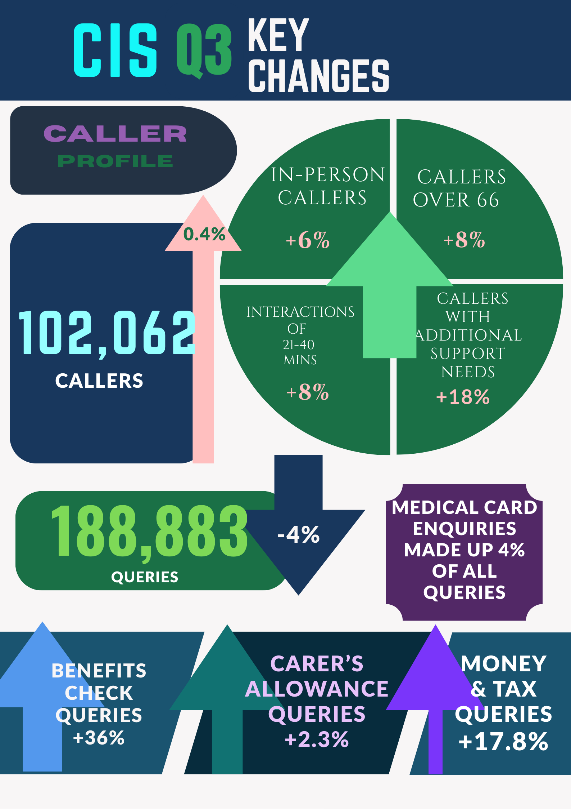

Section 2: Caller Summary

There were 102,062 callers to CISs nationally during Q3, 2025, a small increase on the same period last year (101,610 callers).

Gender Profile

The majority of callers were female (54.7%); males made up 37.4%. The number of couples/family members increased by 8%.
However, ‘Moving Country’ – a category that includes all immigration-related queries – had more male callers than female. ‘Moving Country’ also had the highest percentage of callers with specific needs. Specific needs are recorded by information staff when a caller requires additional help due to, for example, language or literacy difficulties, digital illiteracy, mental health issues, distress, certain disabilities, and other matters that might present additional challenges.

Figure 1 – Caller gender profile

Age Profile
Age information was available for 68.3% of callers (69,720 individuals). The 46–65 age group remained the most frequent users of CIS services, while the 26–45 group – usually comparable in volume – saw a notable decline this quarter, dropping by 10%: the largest shift among all age groups. Callers aged 66 and over increased by 8.4%, they made up 21% of callers up from 19% in the same period last year.

Figure 2 – Caller age profile

Mode of Contact
In-person callers accounted for 71% of interactions, of which 92.5% were drop-in (66,916 callers) and 7.5% were by appointment (5,451 callers). There was an increase of 16% in the number of appointments and an increase of 5.2% in the number of drop-in callers. The number of telephone and letter/email callers decreased.

Figure 3 – Caller mode of contact

Country of Origin
Country of Origin was recorded for 61.9% of callers (63,138 of 102,062 callers). The chart below divides the recorded country of origin into areas of origin. The large majority (73%) came from Ireland (46,109 callers), with non-EU callers representing 19% (11,967) of callers – where country of origin was recorded – and a further 8% with a European Union (excluding Ireland) country of origin (5,062 callers).

Figure 4: Area of origin

Figure 5: Top 5 countries of origin of callers (excluding Ireland)
 | Country of Origin | Number of callers
1 | Ukraine | 1,796
2 | Nigeria | 1,701
3 | Poland | 1,583
4 | Great Britain | 1,011
5 | Bangladesh | 966

Figure 6: Country of origin of callers who contacted CISs most by age cohort (excluding Ireland)
 | Under 25 | 26-45 | 46-65 | 66 and over
1 | Ukraine | Ukraine | Poland | Great Britain
2 | Nigeria | Nigeria | Nigeria | Ukraine
3 | Afghanistan | Poland | Ukraine | USA
4 | Romania | Bangladesh | Great Britain | Poland
5 | Somalia | Romania | Romania | Germany

Specific Needs Identified
In Q2 2025, 17.6% of callers (17,935 people) were identified by information providers as having specific needs that might give rise to barriers to accessing services – and will typically involve additional CIS support – including language, literacy, and online access difficulties.
This represents almost an 18% increase from Q3 2024 in callers identified as having specific needs.
Language continues to be the leading additional need seen by CISs.
Online access and digital literacy issues saw a 55% increase. Nearly three-quarters (72%) of the callers with this additional need were aged over 46.
Over three-quarters (75.9%) of the interactions with callers with specific needs took between 11 and 40 minutes. This compares with 50% of the interactions with all callers.

Figure 7: Specific needs breakdown
Specific Needs | Q3 2025 | % Change Q3 24-Q3 25
Language | 7,136 | +12.8%
Online access issues/ Digital Literacy | 4,396 | +55.1%
Distressed Client | 3,626 | +13.5%
Literacy, Numeracy | 2,695 | +22.2%
Physical Disability | 1,368 | +33.5%
Accompanied/supported by family/ friend/representative | 1,017 | +6.2%
Mental Health | 1,015 | +2.9%
Other | 998 | +90.1%
Sensory Disability | 565 | -2.1%
Homeless | 464 | +29.2%
Challenging Behaviour | 365 | +22.5%

Time Spent

Although four in ten queries were resolved within 10 minutes, longer interactions with information officers, particularly of over 21 minutes, are becoming more common.
- 40.3% of callers spent 10 minutes or less with information providers
- 38.2% of callers spent 11-20 minutes with an information provider
- 17.7% of callers were with an information provider for 21-40 minutes
- 3.6% of callers spent 41-90 minutes with an information provider and
- in a small proportion of cases, interactions lasted for over 90 minutes (0.2%).

Figure 8: Time spent with information staff

Most Frequent Queries (payments/schemes) by Time Spent
The table below gives some indication of the complexity of queries relating to various payments and schemes, according to time spent with information staff.

Figure 9: Top payments/schemes by time spent
 | 10 minutes and under | 11-20 minutes | 21-40 minutes | 41 -90 minutes | 91 minutes and over
1 | Medical Card | Medical Card | Applying for Local Authority/Social Housing | Applying for Local Authority/Social Housing | Basic Supplementary Allowance
2 | Fuel Allowance | State Pension/ Contributory | State Pension/ Contributory | Disability Allowance | Disability Allowance
3 | Carer’s Allowance | Disability Allowance | Medical Card | Medical Card | Jobseeker’s Allowance

Section 3: Query Summary
Services dealt with 188,883 queries during Q3 2025, a decrease of 4.2% on the same period in 2024. The proportion of callers per category remains similar to Q3 2024.
Around 45% of queries were related to social welfare rights and entitlements. Housing queries accounted for 11.5% and Health made up 7.3% of queries.

Figure 10 – Query numbers and proportions by main (level one) category
Query Category | Number of Queries | % of all Queries Q3, ‘25 | % Proportion Change Q3 ’24–Q3 ‘25
Social Welfare | 84,732 | 44.9% | -0.9%
Housing | 21,721 | 11.5% | +0.3%
Health | 13,793 | 7.3% | -0.7%
Local | 13,631 | 7.2% | +0.1%
Money and Tax | 12,353 | 6.5% | +1.2%
Employment | 10,102 | 5.3% | -0.2%
Moving Country | 9,901 | 5.2% | +0.3%
Justice | 4,837 | 2.6% | +0.2%
Travel and Recreation | 4,620 | 2.4% | -0.1%
Education and Training | 3,864 | 2.0% | -0.1%
Birth, Family and Relationships | 3,730 | 2.0% | -0.2%
Consumer Affairs | 2,406 | 1.3% | 0.1%
Government in Ireland | 1,447 | 0.8% | +0.1%
Death and Bereavement | 1,419 | 0.8% | +0.1%
Environment | 327 | 0.2% | 0.0%
 | 188,883 | 100%

Figure 11 – Query number increases/decreases by main (level one) category (%) compared with Q3, 2024

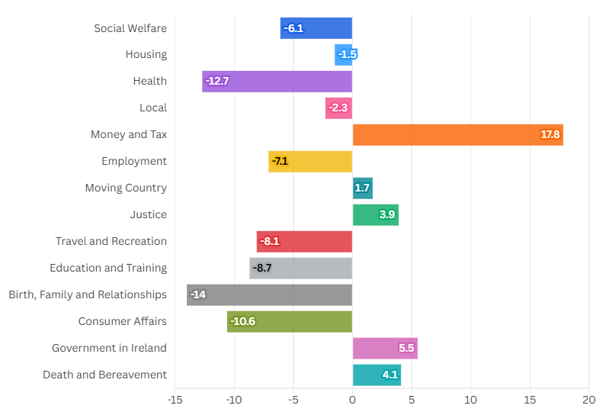

Figure 12 provides a breakdown of the most queried single payments, schemes or entitlements in Quarter 3 2025. Medical card made up 4% of all queries. The ten payments and schemes listed made up over one quarter (27.4%) of all queries this quarter.

Figure 12 – Top ten (i.e. most queried) single payments or schemes
 | Single Payment/ Scheme | # of Queries
1 | Medical Card | 7,633
2 | Disability Allowance | 6,081
3 | Fuel Allowance | 5,830
4 | Carer’s Allowance | 5,789
5 | State Pension /Contributory | 5,749
6 | Applying for Local Authority/Social Housing | 5,733
7 | Jobseeker’s Allowance | 4,114
8 | Household Benefits Package | 3,942
9 | Basic Supplementary Welfare | 3,570
10 | Illness Benefit | 3,219

Section 4: Social Welfare
Social welfare was as ever the most queried area, representing 45% of all queries. The number of social welfare queries declined, however, by 6.1%. Within the social welfare category, the ‘second-tier’ breakdown is as follows:

Figure 13 –Social welfare queries by second-level category
Social Welfare Subcategories | % of overall SW queries |  | % change from Q3 2024
Extra Social Welfare Benefits |  | 15.6% | -10.1%
Disability and Illness |  | 14.6% | -8.3%
Older and Retired People |  | 12.8% | -8.0%
Carers |  | 11.1% | +2.9%
Families and Children |  | 10.4% | -10.7%
Unemployed People |  | 8.9% | -0.1%
Supplementary Welfare Schemes |  | 8.4% | -7.2%
Social Welfare Miscellaneous |  | 5.3% | -3.1%
Social Insurance (PRSI) |  | 5.2% | -8.2%
Benefits Check |  | 2.0% | +36.1%
Activation Schemes, Education and Training Appeals |  | 1.7% | -8.4%
Appeals |  | 1.5% | -9.7%
Death Related Benefits |  | 1.5% | -7.3%
Social Welfare – Payments and Work |  | 0.7% | -24.1%
Farmers |  | 0.2% | +3.1%

For a more detailed (third-tier) breakdown of social welfare query types and trends, see Appendix Figure 1

The chart below offers a comparison of the numbers of queries about specific social welfare payments and schemes, comparing Q3 2024 (the dots) with Q3 2025 (the bars).
Figure 14 – Social welfare payment and schemes query comparison 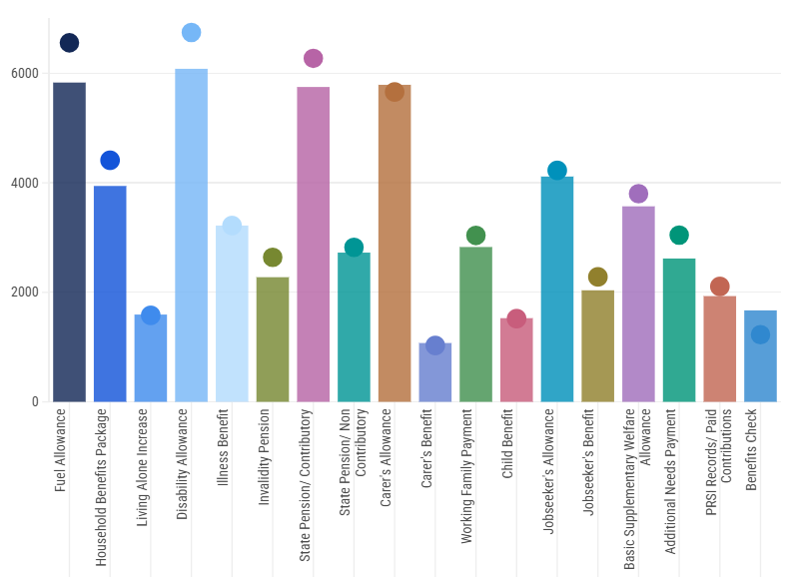

Caller profile data relating to Social Welfare

Age
Figure 15 - Age Breakdown of callers with social welfare queries

The chart below shows the relevance of different topics across age groups. While 46- to 65-year-olds are the most consistent age range making enquiries, significantly the highest number of enquiries under the category ‘Families and Children’ are from 26–45-year-olds.
Figure 16 Age breakdown of callers with social welfare queries by second level category

Gender
Overall, 56.4% of enquiries relating to Social Welfare came from females, followed by 34.3% from males and the rest from couples/families. The only Social Welfare subcategory that had a higher number of enquiries from males was farming, at almost 65%.

Length of Interaction
Of all interactions about social welfare, 42% lasted 11-20 minutes, followed by 31.9% which were 10 minutes and under, then 21.4% lasting 21-40 minutes.

Country of Origin
Most callers who had enquiries about Social Welfare indicated their country of origin as Ireland. Country of Origin was recorded for 66.1% of Social Welfare callers.
- Ireland – 75.9%
- Non-EU - 15.3%,
- EU (excluding Ireland) - 8.8%.

Section 5: Housing
Housing continued to be the second highest category, representing 11.5% of all queries. Housing queries decreased by 1.5% when compared to the same quarter in 2024.
Figure 17: Housing queries by second level category
Housing Subcategories | % of overall housing queries |  | % change from Q3, 2024
Local Authority and Social Housing |  | 52.2% | -0.2%
Housing Grants and Schemes |  | 14.9% | -11.7%
Renting a Home (Private Rental Accommodation) |  | 11.2% | -3.7%
Home Energy Grants (SEAI) |  | 7.8% | +3.5%
Homelessness |  | 4.9% | +11.9%
Other |  | 4.2% | +8.3%
Buying/ Owning a Home |  | 2.8% | -4.7%
Planning Permission |  | 0.7% | +16.0%
Emergency Accommodation |  | 0.5% | -1.0%
Losing your Home |  | 0.4% | -9.6%
Building or Altering a Home |  | 0.3% | +18.6%
Management Companies (Apartment Blocks) |  | 0.2% | -
Equality/ Housing Discrimination |  | 0.1% | -33.3%

For a more detailed (third-tier) breakdown of housing query types and trends, see Appendix Figure 2
The chart below compares the level of queries for the top housing payments and schemes. The circle is the level of queries in Q3 2024, the bars are Q3 2025 levels. Some of the payments and schemes are newly introduced and so have no previous data collected for them.
Figure 18 Housing payment and schemes query comparison
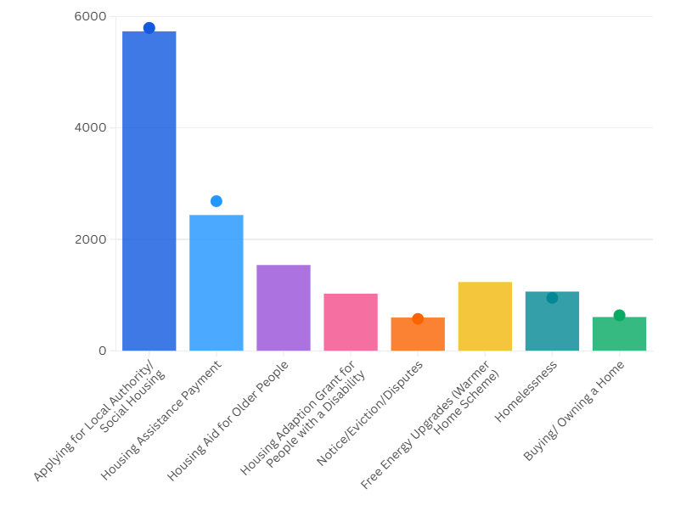

Caller profile data relating to Housing

Age
Figure 19 Age breakdown of callers with housing queries

Figure 20 - Age breakdown of callers with housing queries by second level category

Gender
Overall, most housing queries (51.6%) came from females, followed by 38.5% from males. There were some subcategories, however, Homelessness queries came more from males. Equality/Housing Discrimination queries were equally divided between females and males.

Length of Interaction
Of the interactions related to housing, 41.7% of them lasted 11-20 minutes, 26.5% lasted 21-40 minutes, and 26.4% lasted 10 minutes and under. Overall, housing interactions take longer than the average for all query types.

Country of Origin
Country of origin of the caller was recorded for 61.1% of housing queries, and breaks down as follows:
- Ireland – 67.1%
- Non-EU – 21.3%
- EU (excluding Ireland) – 11.5%.

Section 6: Health
Health queries made up 7.3% of all queries, the overall number of health queries declining by 12.7%. Medical Card continues to be by far the most queried sub-category under health: over 55% of all health queries.
Figure 21: Health queries by second level category
Subcategory Breakdown | # of Queries | % of Subcategory | % Change
Medical Card | 7,633 | 55.3% | -21.5%
GP Visit Card | 840 | 6.1% | +4.2%
Fair Deal & Home Care Package | 820 | 5.9% | -12.7%
Other | 720 | 5.2% | +0.6%
GP Services | 585 | 4.2% | +12.1%
Drugs/ Medicine | 500 | 3.6% | -11.5%
-Drugs Payments Scheme | 351
-Long-term Illness Scheme | 149
Health Services for Older People | 291 | 2.1% | -4.6%
Hospital Services | 280 | 2.0% | +3.7%
Dental, Aural and Optical Health | 247 | 1.8% | -12.7%
Care in your Community | 219 | 1.6% | -6.8%
EU Healthcare | 218 | 1.6% | -19.0%
Mental Health | 187 | 1.4% | -3.6%
Health Services for People with Disabilities | 176 | 1.3% | 0.0%
Legal Matters and Health | 162 | 1.2% | +30.6%
Cancer Services | 118 | 0.9% | +57.3%
Health Insurance | 113 | 0.8% | +6.6
Children’s Health | 93 | 0.7% | -14.7%
Cross-Border Healthcare | 93 | 0.7% | -
Entitlement to Health Services | 90 | 0.7% | -10.0%
Health Related Benefits and Entitlements | 75 | 0.5% | +2.7%
Women’s Health | 61 | 0.4% | +205.0%
Health Service Agencies | 48 | 0.3% | +2.1%
Aids and Appliances | 46 | 0.3% | +39.4%
Alcohol and Drug Treatment Services | 42 | 0.3% | +16.7%
Pharmacy Services | 35 | 0.3% | +25.0%
Emergency Health Services | 32 | 0.2% | +52.4%
Blind Welfare Allowance | 29 | 0.2% | -
How Health Services are Organised | 28 | 0.2% | +40.0%
Blood and Organ Donation | 5 | 0.0% | +150.0%
Alternative Health | 4 | 0.0% | +300.0%
Environmental Health | 3 | 0.0% | -62.5%
Total Health Queries 13,793

The chart below shows a comparison of the level of queries for the top health payments and schemes in Q3 2024 and Q3 2025. The circle is the level of queries in Q3 2024, the bars are Q3 2025 levels.

Figure 22: Health payment and schemes query comparison
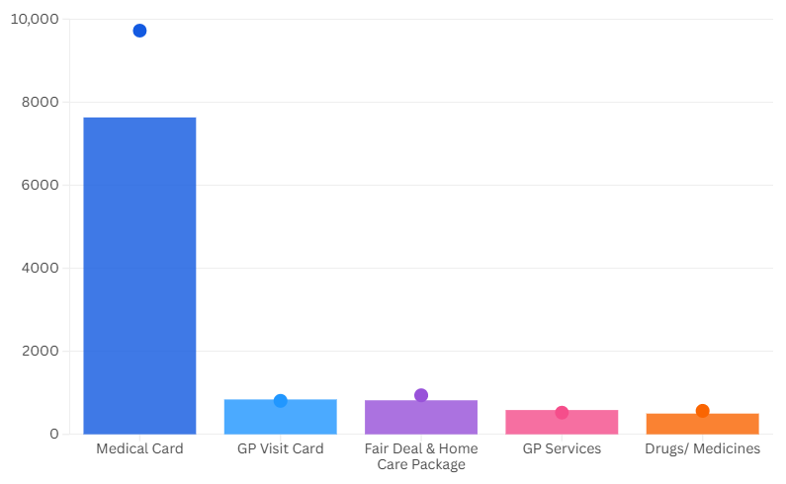

Caller profile data relating to health queries

Age
Figure 23: Age Breakdown of Health callers

Figure 24: Age Breakdown of callers with health queries, by second level category

Gender
Overall, as in other categories, most health enquiries (52.8%) came from females, followed by 36.7% from males. Couples and family members made up 9.2% of callers with health queries.

Country of Origin
Below we can see that, where recorded, just over three-quarters of callers with health queries indicated Ireland as their country of origin. Country of origin was recorded for 64.2% of callers with health queries.
- Ireland – 76.0%
- Non-EU - 15.7%,
- EU (excluding Ireland) – 8.3%.

Length of Interaction
Over one third (36.4%) of interactions lasted 10 minutes or less. Similarly to the same period last year, more than 37% of health interactions lasted 11-20 minutes and 21.6% took 21-40 minutes.

Section 7: Other Query Areas
This section offers an overview of the query categories that are not profiled in more detail above and in the appendix. The query comparisons, as throughout this report, are between Q3, 2024 and Q3, 2025. The numbers in brackets are the number of queries in this current quarter: Q3, 2025.
The only major query category not profiled here is ‘Local’, which has no second level categories. Queries categorised as ‘local’ decreased slightly this quarter to 13,631 (compared with 13,957 for Q3, 2024)

Money and Tax
Queries about money and tax increased by 17.8% (12,353). This runs counter to the overall trend and is accounted for mainly by rises in enquiries about income tax and Revenue Online.

Figure 25: Money & tax top five second-level categories
Money & Tax second level category | Number of queries | Percentage change from Q3, 2024
Income Tax | 2,731 | +32.5%
Income Tax Credits & Reliefs | 2,433 | +14%
Revenue Online | 1,944 | +20.9%
Other | 1,009 | +10.8%
Income Tax Refund | 813 | +20.3%

Employment
Queries on employment decreased by 7.1% (10,102), though some areas increased, including ‘Enforcement and Redress’ and ‘Grievance & Discipline Procedures’.

Figure 26: Employment second-level categories
Employment second level category | Number of queries | Percentage change from Q3, 2024
Employment Rights & Conditions | 5,606 | -11.8%
Unemployment & Redundancy | 960 | -6.3%
Self-employment | 840 | -10.4%
Enforcement & Redress | 670 | +4.2%
Grievance & Discipline Procedures | 442 | +23.8%

Moving Country
Queries categorised as ‘Moving County’ increased by 1.7% (9,901). This category includes all immigration queries, and the increase is partially down to a doubling of queries about Irish Residence Permit applications and renewals.

Figure 27: Moving country top five second-level categories
Moving Country second level category | Number of queries | Percentage change from Q3, 2024
Irish Citizenship | 2,761 | -6.9%
Irish Residence Permit | 1,432 | +87.4%
Visa | 763 | -11%
Ukrainian Asylum Seekers/Refugees | 510 | -24.9%
Asylum Seekers/Refugees | 481 | -2.2%

Other Areas
Here we list those minority query areas that form part of CIS general remit but attract less enquiries than the areas profiled above. They are listed in order of the number of queries received, with the top two second-level categories listed in each case. The two least-queried categories overall - ‘Government in Ireland’ and ‘Death and Bereavement’ - are the only ones showing an overall increase.

Justice queries decreased by 3.9% (4,837), though Legal Aid queries stayed constant.
- Legal Aid and Advice queries remained at a similar level (2,211).
- Civil Law queries decreased by 1.8% (380).
Travel and Recreation queries decreased by 8.1% (4,620), with passport queries down and motoring queries up.
- Motoring queries increased by 9.7% (1,994).
- Passport queries decreased by 17.1% (1,509).
Education and Training queries decreased by 8.7% (3,864 queries).
- Third-Level Education queries decreased by 5.6% (1,846).
- Vocational Education and Training queries decreased by 10.4% (596).
Birth, Family and Relationships queries decreased by 14% (3,730).
- Separation and Divorce queries decreased 19.1% (1,038).
- Maintenance queries decreased by 14% (474).
Consumer Affairs queries decreased by 10.6% (2,406).
- Consumer Protection queries remained at a similar level (530).
- Energy/Utilities Services queries decreased by 13.1% (464).
Government in Ireland queries increased by 5.5% (1,447).
- MyGovID queries increased by 33.9% (747).
- FOI queries decreased by 18% (141).
Death and Bereavement queries increased by 4.1% (1,419).
- The Deceased’s Estate queries decreased by 3.1% (409).
- Before Death queries increased by 8.8% (283)

Section 5: Appendix –Breakdown of top three query areas by third level category

Appendix Figure 1 – Social Welfare Query Breakdown
Third level category breakdown (second level category in bold) | # of Queries | % of Subcategory | % Change
Extra Social Welfare Benefits 15.6%
Fuel Allowance | 5,830 | 44.1% | -11.1%
Household Benefits Package | 3,942 | 29.8% | 10.6%
Living Alone Increase | 1,594 | 12.1% | +0.9%
Free Travel (Travel Card, Companion Card, etc) | 1,560 | 11.8% | -11.5%
Telephone Support Allowance | 154 | 1.2% | -37.7%
Treatment Benefits | 99 | 1.2% | +0.0%
Cost of Living Increases | 26 | 0.2% | +4.0%
Christmas Bonus | 18 | 0.1% | -30.8%
Total | 13,223 | 100% | -10.1%
Disability and Illness 14.6%
Disability Allowance | 6,081 | 49.0% | -9.8%
Illness Benefit | 3,219 | 25.9% | +0.0%
Invalidity Pension | 2,276 | 18.3% | -13.7%
Partial Capacity Benefit | 451 | 3.6% | -9.4%
Injury Benefits | 164 | 1.3% | -1.8%
Other Payment (Blind Pension/Other) | 115 | 0.9% | -21.8%
Occupational Injuries Benefit Scheme | 107 | 0.9% | -15.7%
Total | 12,413 | 100% | -8.3%
Older and Retired People 12.8%
State Pension Contributory | 5,749 | 53.0% | -8.3%
State Pension Non-Contributory | 2,725 | 25.1% | -3.4%
Payment for people who retire at 65 | 765 | 7.1% | -7.5%
Qualified Adults | 501 | 4.6% | -15.7%
Homemakers Scheme/Home-Caring Periods Scheme | 465 | 4.3% | -2.1%
UK Pensions/Brexit | 440 | 4.1% | -25.8%
EU/ International Pensions | 204 | 1.9% | -3.8%
Total | 10,849 | 100% | -8.0%
Carers 11.1%
Carer's Allowance | 5,789 | 61.3% | +2.3%
Carer's Benefit | 1,074 | 11.4% | +4.4%
Domiciliary Care Allowance (DCA) | 986 | 10.4% | -7.2%
Carer's Support Grant (Respite Care Grant) | 914 | 9.7% | +11.5%
Half-rate Carer's Allowance | 684 | 7.2% | +12.5%
Total | 9,447 | 100% | +2.9%
Families and Children 10.4%
Working Family Payment (WFP) | 2,827 | 32.0% | -7.0%
Child Benefit | 1,528 | 17.3% | +0.6%
One Parent Family Payment (OFP) | 1,451 | 16.4% | -10.3%
Back to School Clothing & Footwear Allowance | 1,233 | 14.0% | -16.5%
Maternity/ Adoptive Benefit | 482 | 5.5% | -26.2%
Benefit Increase for a Qualified Adult (IQA) | 443 | 5.0% | -10.9%
Child Support Payment (IQC) | 323 | 3.7% | -14.8%
Parent's Benefit | 220 | 2.5% | -27.2%
Paternity Benefit | 136 | 1.5% | -29.9%
Back to Work Family Dividend | 129 | 1.5% | -12.2%
Health and Safety Benefit | 31 | 0.4% | +0.0%
Deserted Wife's Benefit | 16 | 0.2% | -20.0%
Deserted Wife's Allowance | 2 | 0.1% | -33.3%
Total | 8,821 | 100% | -10.7%
Unemployed People 8.9%
Jobseeker's Allowance | 4,114 | 54.4% | -2.7%
Jobseeker's Benefit | 2,037 | 27.0% | -10.7%
Jobseeker's Pay-Related Benefit | 510 | 6.7% | -
Jobseeker’s Transitional | 437 | 5.8% | -14.8%
Social Welfare Payments and Work | 363 | 4.8% | -21.3%
Unemployed following self-employment | 97 | 1.3% | +11.5%
Total | 7,558 | 100% | -0.1%
Supplementary Welfare Schemes 8.4%
Basic Supplementary Welfare Allowance | 3,570 | 49.9% | -6.1%
Additional Needs Payment | 2,617 | 36.6% | -14.1%
Rent Supplement (RS) | 884 | 12.3% | +9.3%
Diet/Heating Supplement | 60 | 0.8% | +3.4%
Humanitarian Assistance | 25 | 0.3% | -
Mortgage Interest Supplement (MIS) | 2 | 0.0% | -33.3%
Total | 7,158 | 100% | -7.2%
Social Welfare Miscellaneous 5.3%
Other | 1,411 | 31.2% | +0.2%
Public Services Card | 829 | 18.3% | -2.7%
Habitual Residence Condition | 680 | 15.0% | +2.9%
Means Tests | 598 | 13.2% | -21.8%
MyWelfare.ie | 493 | 10.9% | +17.9%
Overpayments | 298 | 6.6% | -9.7%
Nominating agent to collect SW payments | 56 | 1.2% | +133.3%
SW Inspectors | 46 | 1.0% | +119.0%
EU Contributions and Entitlements | 45 | 1.0% | -45.1%
UK Entitlements /Brexit | 41 | 0.9% | -44.6%
Late Claims | 22 | 0.5% | -15.4%
EU/EEA/Switzerland | 6 | 0.1% | -14.3%
Insolvency Payments Scheme | 2 | 0.0% | -50.0%
Total | 4,392 | 100% | -3.1%
Social Insurance (PRSI) 5.2%
PRSI Records/Paid Contributions | 1,931 | 44.0% | -8.4%
PPS Number | 774 | 17.6% | -13.9%
Credited Contributions | 401 | 9.1% | -2.9%
Voluntary Contributions | 373 | 8.5% | +12.3%
Homemakers Scheme/HomeCaring Periods Scheme | 342 | 7.8% | -2.0%
PRSI Classes | 295 | 6.7% | -2.0%
Other | 139 | 3.2% | -16.8%
Long-Term Carer Contributions | 92 | 2.1% | -47.7%
Employer’s PRSI | 45 | 1.0% | +18.4%
Total | 4,392 | 100% | -8.2%
Benefits Check 2.0%
Benefits Check | 1,670 |  | +36.1%
Total | 1,670 | 100%
Activation Schemes, Education and Training 1.7%
Back to Education Allowance (BTEA) | 704 | 48.5% | -11.2%
Community Employment (CE) | 266 | 18.3% | +1.5%
Back to Work Enterprise Allowance (BTWEA) | 254 | 17.5% | -9.3%
Tús | 56 | 3.9% | -3.4%
Part-time Education Option (PTEO) | 39 | 2.7% | -15.2%
JobPath - Seetec/Turas Nua | 34 | 2.3% | +25.9%
LAES (Local Area Employment Services) | 21 | 1.4% | -16.1%
Rural Social Scheme | 20 | 1.4% | -4.8%
Short-Term Enterprise Allowance | 17 | 1.2% | -51.4%
Part-Time Job Incentive Scheme (PTJI) | 15 | 1.0% | -16.7%
Work Placement Experience Programme (WPEP) | 12 | 0.8% | +100.0%
JobsPlus | 10 | 0.7% | -23.1%
Gateway | 3 | 0.2% | +200.0%
JobBridge/ First Steps – Youth Internship | 1 | 0.1% | -
Total | 1,452 | 100% | -8.4%
Appeals 1.5%
Disability Allowance | 429 | 33.6% | -18.6%
Carer’s Allowance/Benefit | 238 | 18.7% | +29.3%
Invalidity Pension | 197 | 15.5% | -1.0%
Other | 102 | 8.0% | -14.3%
Jobseeker's Allowance | 94 | 7.4% | -19.7%
Domiciliary Care Allowance | 48 | 3.8% | -23.8%
Supplementary Welfare Allowance | 37 | 2.9% | -31.5%
State Pension (Non-Contributory) | 20 | 1.6% | -39.4%
Child Benefit | 19 | 1.5% | +18.8%
Illness Benefit | 19 | 1.5% | +26.7%
Jobseeker's Benefit Child Benefit | 17 | 1.3% | -5.6%
Carer's Support Grant | 15 | 1.2% | +36.4%
One Parent Family Payment (OFP) | 14 | 1.1% | +7.7%
Working Family Payment (WFP) | 13 | 1.0% | -31.6%
State Pension (Contributory) | 11 | 0.9% | -50.0%
Bereaved Partner’s Pension | 2 | 0.2% | 0.0%
Total | 1,452 | 100% | -9.7%
Death Related Benefits 1.5%
Bereaved Partner's Pension (Contributory) | 790 | 63.7% | +1.2%
Bereaved Partner's Pension (Non-Contributory) | 153 | 12.3% | -11.6%
Help with Funeral Costs | 144 | 11.6% | -23.4%
Widow/Widower/Surviving Civil Partner Grant | 88 | 7.1% | -20.0%
Guardian's Payment | 47 | 3.8% | -39.7%
Special Funeral Grant (Occ. Injuries Scheme only) | 19 | 1.5% | +111.1
Total | 1,241 | 100% | -7.3%
Payments and Work 0.7%
Payments and Work | 573 |  | -24.1%
Total | 573 | 100%
Farmers 0.2%
Farm Assist | 120 | 90.2% | +1.7%
Other | 13 | 9.8% | +18.2%
Total | 133 | 100% | +3.1%
Total Social Welfare Queries 76,240

Appendix Figure 2 – Housing Queries Breakdown
Subcategory Breakdown | # of Queries | % of Subcategory | % Change
Local Authority and Social Housing 52.2%
Applying for Local Authority/Social Housing | 5,733 | 50.6% | -1.1%
Housing Assistance Payment (HAP) | 2,436 | 21.5% | -9.2%
Other | 730 | 6.4% | +0.7%
Differential Rent | 340 | 3.0% | +12.2%
Medical Priority | 317 | 2.8% | +8.6%
Choice Based Lettings | 296 | 2.6% | +61.7%
Social Housing Waiting Lists | 286 | 2.5% | +43.0%
LA Transfers | 247 | 2.2% | -2.8%
Approved Housing Bodies (AHBs) | 184 | 1.6% | +12.2%
Standards/Repairs | 153 | 1.3% | -12.1%
Rent Arrears/Rent Problems | 123 | 1.1% | +7.0%
Tenant in situ (HAP/RAS) | 96 | 0.8% | +17.1%
Notice/Eviction/Disputes | 90 | 0.8% | +11.1%
Anti-social behaviour | 84 | 0.7% | +3.7%
Rental Accommodation Scheme (RAS) | 78 | 0.7% | -17.9%
Tenant Purchase (Incremental Scheme) | 75 | 0.7% | -13.8%
Tenancy Succession | 51 | 0.4% | +21.4%
Traveller Accommodation | 19 | 0.2% | +111.1%
Total | 11,338 | 100% | -0.2%
Housing Grants and Schemes 14.9%
Housing Aid for Older People | 1,538 | 47.7% | -
Housing Adaption for People with Disability | 1,024 | 31.7% | -
Other | 296 | 9.2% | -
Mobility Aid Grant Scheme | 230 | 7.1% | -
Vacant Property Refurbishment Grant | 138 | 4.3% | -
Total | 3,070 | 100% | -11.7%
Renting a Home (Private Rental Accommodation) 11.2%
Notice/Eviction/Disputes | 596 | 24.6% | +4.2%
RTB (Residential Tenancies Board) | 386 | 15.9% | -5.9%
Landlords' Rights and Obligations | 341 | 14.1% | -1.2%
Tenants' Rights & Obligations | 330 | 13.6% | -12.5%
Rent Review | 181 | 7.5% | -16.2%
Finding Accommodation | 170 | 7.0% | -2.9%
Standards/Repairs | 90 | 3.7% | -15.1%
Deposit Retention | 88 | 3.6% | +11.4%
Rent Arrears/Rent Problems | 76 | 3.1% | -26.2%
Licensee | 71 | 2.9% | +31.5%
Cost Rental Housing | 39 | 1.6% | +44.4%
Short-term rental lets | 31 | 1.3% | -8.8%
Cost Rental – Tenant in situ scheme | 21 | 0.9% | +90.9%
Non-Resident Landlords (Withholding Tax) | 3 | 0.1% | -50.0%
Total | 2,202 | 100% | -3.7%
Home Energy Grants (SEAI) 7.8%
Free Energy Upgrades (Warmer Homes Scheme) | 1,233 | 73.0% | -
Individual Energy Upgrades | 235 | 13.9% | -
Complete Home Energy Upgrades | 222 | 13.6% | -
Total | 1,690 | 100% | +3.5%
Homelessness 4.9%
Homelessness | 1,062
Total | 1,062 | 100% | +11.9%
Other 4.2%
Other | 911
Total | 911 | 100% | +8.3%
Buying/Owning a Home 2.8%
Buying/ Owning a Home | 605
Total | 605 | 100% | -4.7%
Planning Permission 0.7%
Planning Permission | 145
Total | 145 | 100% | +16.0%
Emergency Accommodation 0.5%
Emergency Accommodation | 98
Total | 98 | 100% | -1.0%
Losing your Home 0.4%
Losing your Home | 94
Total | 94 | 100% | -9.6%
Building or Altering a Home 0.3%
Building or Altering a Home | 70
Total | 70 | 100% | +18.6%
Management Companies (Apartment Blocks) 0.2%
Management Companies (Apartment Blocks) | 41
Total | 41 | 100% | 0.0%
Equality/ Housing Discrimination 0.1%
Equality/ Housing Discrimination | 18
Total | 18 | 100% | -33.3%
Total Housing Queries 21,721

