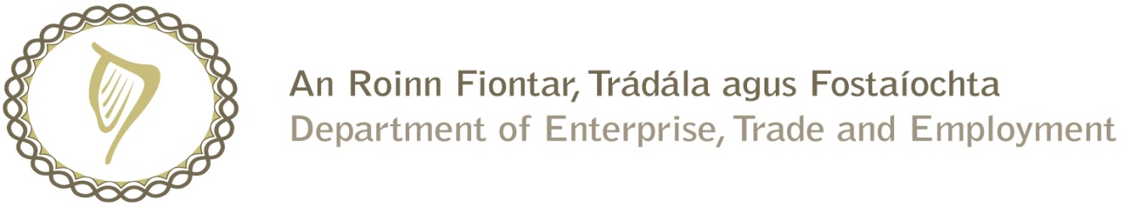

Prompt Payments by Central Government Departments

Reporting Template pursuant to Government Decision No. S29296 of 19 May 2009

Government Department: Social Protection____________

Quarterly Period Covered: October 2016 to December 2016_

Details | Number | Value (€) | Percentage (%) of total payments made
Total payments made in Quarter | 703 | 11,968,247.70 | 100
Number of payments made within 15 days | 635 | 11,820,369.60 | 90.33
Number of payments made within 16 days to 30 days | 54 | 53,841.00 | 7.68
Number of payments made in excess of 30 days | 11 | 93,686.02 | 1.56
Disputed Invoices | 3 | 351.08 | 0.43
Total | 703 | 11,968,247.70 | 100

Signed: Gary Watters

Finance & Administration Manager

Date: 10th Jan 2017

