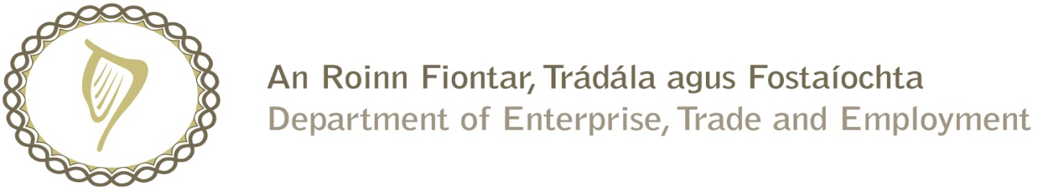

Prompt Payments by Central Government Departments

Reporting Template pursuant to Government Decision No. S29296 of 19 May 2009

Government Department: DSP (Citizens Information Board)

Quarterly Period Covered: July 2016 to Sept 2016

Details | Number | Value (€) | Percentage (%) of total payments made
Total payments made in Quarter | 516 | 11,354,351.99 | 100
Number of payments made within 15 days | 407 | 11,021,954.05 | 78.88
Number of payments made within 16 days to 30 days | 76 | 257,826.33 | 14.73
Number of payments made in excess of 30 days | 30 | 68,201.14 | 5.81
Disputed Invoices | 3 | 6,370.47 | 0.58
Total | 516 | 11,354,351.99 | 100

Signed: David Stratton

Finance Executive

Date: 3rd Oct 2016

