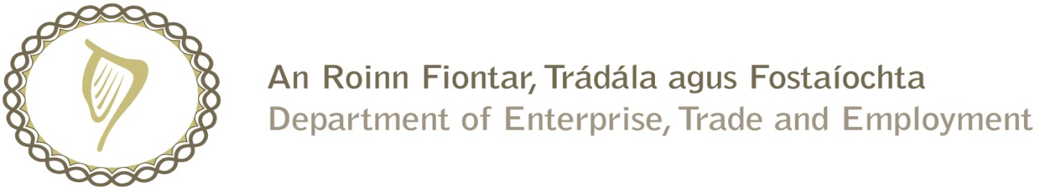

Prompt Payments by Central Government Departments

Reporting Template pursuant to Government Decision No. S29296 of 19 May 2009

Government Department: DSP (Citizens Information Board)

Quarterly Period Covered: April 2016 to June 2016_

Details | Number | Value (€) | Percentage (%) of total payments made
Total payments made in Quarter | 553 | 10,186,234.61 | 100
Number of payments made within 15 days | 474 | 9,941,743.16 | 85.7
Number of payments made within 16 days to 30 days | 58 | 223,713.72 | 10.5
Number of payments made in excess of 30 days | 17 | 13,658.64 | 3.1
Disputed Invoices | 4 | 7,119.09 | 0.7
Total | 553 | 10,186,234.61 | 100

Signed: David Stratton

Finance Executive

Date: 5th July 2016

