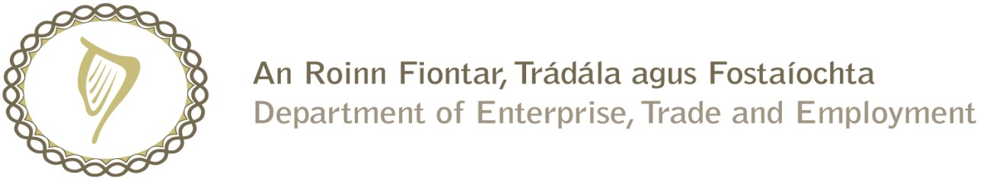

Prompt Payments by Central Government Departments

Reporting Template pursuant to Government Decision No. S29296 of 19 May 2009

Government Department: DSP (Citizens Information Board)

Quarterly Period Covered: January 2016 to March 2016_

Details | Number | Value (€) | Percentage (%) of total payments made
Total payments made in Quarter | 509 | 10,970,281.87 | 100
Number of payments made within 15 days | 385 | 6,735,261.60 | 75.6
Number of payments made within 16 days to 30 days | 112 | 4,228,554.13 | 22
Number of payments made in excess of 30 days | 8 | 5,704.28 | 1.6
Disputed Invoices | 4 | 761.86 | 0.8
Total | 509 | 10,970,281.87 | 100

Signed: David Stratton

Finance Executive

Date: 1st April 2016

