Issue 17 Speaking Up March 2013
------------------------------------------------------------------------------------------
Page 1

Advocacy and the Social Welfare System

Susan Ryan, Development Manager, Co Offaly CIS
A very successful seminar: Advocacy and the Social Welfare System, was recently organised by Offaly Citizens Information Service, through the Advocacy Support Worker Programme. This programme commenced in 2011 with the aim of building advocacy capacity within the Citizens Information Network. The main target audience was CIS Information Officers and Development Managers but people from the National Advocacy Service, Northside Community Law Centre, Mercy Law Centre and the Social Welfare Appeals Office also attended. Altogether there were 103 participants some from as far away as Donegal, Clare, Cavan and Crumlin!

Saoirse Brady, FLAC Policy and Advocacy Officer and author of “Not Fair Enough: Making the case for reform of the social welfare appeals system (2012), made the opening address to an appreciative audience. Professor Gerry Whyte of Trinity College Law School followed and addressed decision-making processes within the Department of Social Protection and the Appeals Office, focusing on claimant issues. He also spoke on legislation, statutory instruments and social welfare case law.
Derek Shortall BL, a practicing barrister specializing in the area of Social Welfare Law, then dealt with EU Law and the Social Welfare Appeals process. He covered a range of technical areas such as EU Migrant Worker Status, Right to Reside, Habitual Residence Conditions, and Judicial Review, including relevant EU directives and case law. This particular part of the session was hugely informative and raised challenging questions around the interaction of EU Law and our Welfare System. The comment: “This area could have taken a full day on its own” illustrates the complex issues that Citizens Information Services face when dealing with EU Legislation and our welfare system.
There were question and answer sessions after both lectures which expanded on the issues raised and demonstrated the level of expertise in the audience.
In his concluding remarks Jim Stone, Co. Offaly CIS Chairperson, thanked participants and particularly the three ASW organisers, Grainne Griffin, Sheila Kilkerr and Philip Judge.

Feedback on the day was positive and included comments like: “Finally a training addressing social welfare at a higher and European level” “This seminar has been a great source of information for me in my role as an advocate” “Excellent!”
We are already looking forward to next year’s seminar!
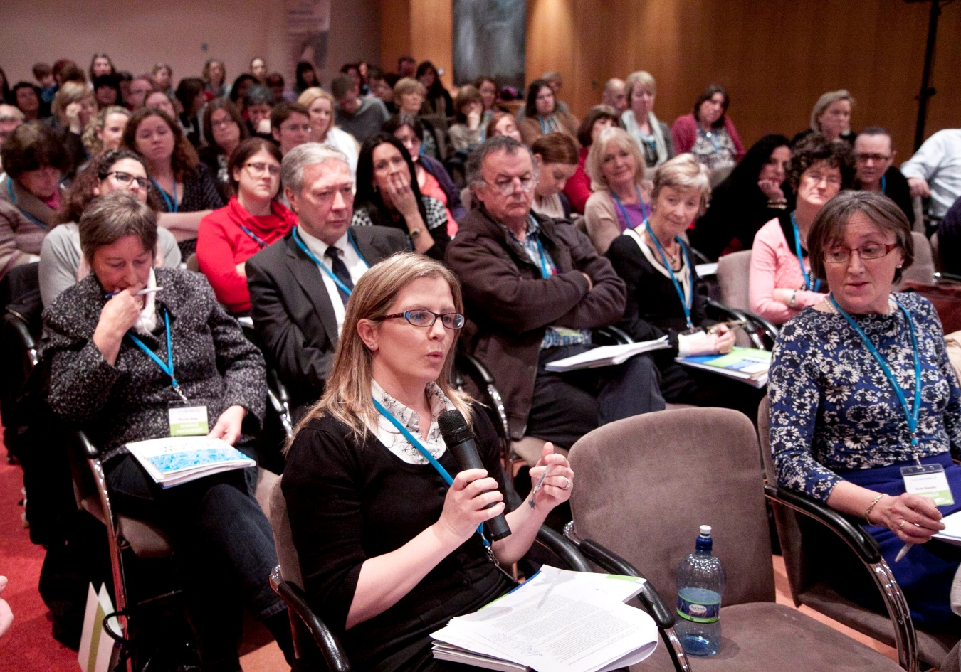

Attendees at the seminar

-------------------------------------------------------------------------------------
Page 2

Safeguarding Adults in Bristol

The Bristol Safeguarding Adults Board (BSAB) is a strategic alliance of key organisations working together to ensure that Safeguarding Adults work in Bristol is effective, responsive and co-ordinated. The board is committed to stopping all forms of financial, emotional, physical, sexual, discriminatory, institutional abuse or neglect in its aim to safeguard and protect all adults living in Bristol. It defines as an adult at risk or a vulnerable adult, someone over 18 who has, or may need, help with their everyday living tasks and who is, for any reason, unable to protect themselves. BSAB adopts their philosophy statement in accordance with the principles contained within the European Convention on Human Rights and the Human Rights Act 1998.

They commit to ensuring that any necessary measures e.g. advocacy, interpreters etc. are provided, to support and empower individuals who are being allegedly harmed by a third party, to decide what action, if any, will be taken. Where an adult does not have the capacity to consent to actions taken to protect them it should be clarified who, if anyone, has the power to act on their behalf.

Adults defined as an adult at risk or vulnerable adult:
- have the right to live their lives free from coercion, intimidation, oppression and physical, sexual emotional or mental harm;
- have a right to a family life and privacy;
- have a right to confidentiality in respect of personal information insofar as this does not infringe the rights of other people;
- have the right to receive full and comprehensive information to enable them to make informed choices about their own circumstances;
- have the right to the protection of the law and access to the judicial process.

.

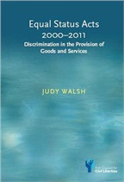

Uncharted Waters
A high-profile equality conference in Dublin heard that cases under the Equal Status Acts, which prohibit discrimination in the provision of goods and services, are entering “uncharted waters”. The conference, The Future of Anti-Discrimination Law in Ireland, marked the publication of an authoritative new legal text book on the Equal Status Acts by Judy Walshe. Mr. Mark Kelly ICCL director, noted the uncertainty around the merger processes involving the Equality Authority and the Equality Tribunal, and the need to reassure potential clients.
In 2013 it is planned to merge the Equality Authority with the Irish Human Rights Commission and to make the Equality Tribunal part of the new Workplace Relations Commission.

Page 3

Using Case Studies: to demonstrate work or influence policy

Media coverage often require case examples to illustrate an issue and there is no doubt that relating the real life experience of people is the best way to do this. However care is always needed to ensure that the person’s privacy is safeguarded and that their story is sufficiently changed to protect their confidentiality. Anonymised data is not considered personal data under the Data Protection Acts. For all reports CIB changes personal details as well as names, locations and other identifying features. However it is impossible to ensure that a person who had worked with a particularly complex case never recognises it, even when anonymised.

These issues are discussed in a recent UK report from the UK Information Commissioner’s Office, Anonymisation: managing data protection risk: code of practice.

Two Cases
Jarlath had lived part-time in a residential service and spent weekends at home with his parents. He is very sociable and interacts well with friends in the service. His parents could no longer have him home at weekends and the service did not have a seven day place. Jarlath needs communication supports but because different methods were used in different settings, this did not help him to communicate. The advocate spent time getting to know Jarlath, his family and his residential service and consulted with the various people in his life on how best to introduce change to Jarlath and how best to safeguard his rights and to give him opportunities in areas where he shows an interest.

The advocate tried to make sure that Jarlath had more input into the plans that were being made for his future. As an interim measure his family were offered weekend supports and Jarlath also began working with a Speech & Language Therapist. Later a full residential place became available in Jarlath’s week-day centre and a transition plan was set up to prepare him for the change. Regular contact with his family and involvement in his home community will continue.

Page 4

Focussed Review of the National Advocacy Service for People with Disabilities
A Review of the National Advocacy Service was presented to the CIB board in March 2013.
This Round Table Solutions review was commissioned in 2012 to look at caseload management, the structure of the service and whether aspects of the Citizens Information Act relating to statutory powers for NAS advocates be introduced or amended.

So Now to Implementation?
Kathleen Lynch T.D., Minister for Disability, Equality, Mental Health & Older People published the Value for Money and Policy Review of the Disability Services in July 2012.
The Report recommends a transition towards a model of person-centred, individually chosen supports and the implementation of a more effective method of assessing need, allocating resources and monitoring resource use. In launching the report, the Minister stated that “Individualised budgeting is an approach whereby a monetary value is placed on the supports required by the individual to live a fully included life in the community. The essence of individualised budgeting is that the person is given more choice and control over how the money allocated to meet their needs is utilised. This approach must be underpinned by a standardised needs assessment to ensure fairness and transparency in the way in which funding is allocated”.
The report holds that the cost of providing funding under the present model is unsustainable. The Expert Group attempted to compare costs for providing services across different agencies, both HSE and voluntary, but met with difficulties because of the variety of ways of assessing costs and client needs, different accounting systems and the absence of any costings by some agencies receiving block grants. With the limited information available to it, the Expert Group found considerable variation of costs across agencies which appeared to be offering similar services.
The Comptroller and Auditor General’s report of March 2013 concludes that “There is scope for a more holistic approach to planning the provision of services to persons with disability and there is a need to integrate services procured from non-profit organisations into national plans. The comparative cost of services provided by non-profit organisations needs to be assessed by reference to the cost of direct provision”.

National Advocacy Service Annual Report 2012 Statistics
NAS client statistics by year | 2011 | 2012 | % change
on Books at Start of Period | 206 | 573 | 178%
Total NAS clients for year | 856 | 1068 | 25%
New Cases | 650 | 495 | -24%
Closed Cases | 291 | 411 | 41%
Initial Interview | 748 | 872 | 17%
Waitlist | 34 | 20 | -41%
Average clients per advocate (35) | 23 | 31

Page 5

Empowering Parents with Learning Difficulties

CIB is funding DESSA to pilot the “Empowering Parents Programme” a self-advocacy programme for parents with learning difficulties. The programme seeks to develop the confidence and competence of parents to speak up for themselves, to provide a positive peer support network and to connect parents to locally-based support structures, in order to counter a range of barriers which in their experience inhibit their ability to parent including :
- Low self-esteem and lack of confidence on their part
- Negative assumptions that learning difficulty automatically equates with an inability to parent.
- Negative stereotypes that parents with learning difficulties could never be good enough parents.
- Lack of clarity and consistency among professionals on what constitutes good parenting.
- Mainstream services that lack capacity to work with parents with learning difficulties.

Parents identify social isolation as a major issue. Lack of access to relevant information and a lack of opportunity to share their experiences add to this isolation. Parents may also be fearful of asking for help with their parenting and face a range of other disadvantages such as unemployment, poverty and mental health difficulties.

A key feature of this project is the delivery of the programme through a designated Family Resource Centre (FRC). FRCs offer mainstream community-based family supports for all families experiencing social exclusion and marginalisation. In working with FRCs DESSA anticipates that parents with learning difficulties and their children will become more connected to their local communities.

Supported Decision Making trial in Australia
The Office of the Public Guardian Supported Decision Making project in Southern Australia aimed to assist people with a disability to set up non-statutory-supported decision-making agreements. The project was evaluated in November 2012. Agreements were set up for people who had experienced an acquired brain injury, autism, intellectual disability, or a neurological disease affecting decision -making. Participants nominated areas of decision making in which they wished to receive support including personal care, support services, housing, diet, medical procedures, general health care, travel and the use of alcohol.
The independent evaluator concluded that the project provided specific benefits to most participants. These included increased confidence in decision making, improved decision making skills, and a feeling of greater control in people’s lives. The evaluation gave evidence that Supported Decision Making is both a companion process and viable alternative to substitute decision making for participants who were initially on guardianship orders.
“People with a lived experience of disability pointed out the need to build up confidence in decision making. From a young age people can be subtly taught that decisions are for others to make, and their role may at best be to express a view. This particularly applies to those who have had a lot of dealings with institutions or traditional service systems”. For this reason they took “a strengths based approach, building on what a person can do, rather than a traditional deficit based approach. Although our project is in its early phase, we expect as people get more practice at making decisions, they will develop confidence, and the need for decision support will decrease”.
Page 6

Date for your Diary
CIB is hosting an Advocacy Conference in Dublin Castle on Monday September 9th 2013.

More Transparency and Accountability in Child Protection Cases
The Child Care Law Reporting Project has been established in Ireland under the direction of Doctor Carol Coulter, to examine and report on child care proceedings in the courts, under Section 3 of the Child Care (Amendment) Act 2007. It aims to:
- Provide information to the public on child care proceedings in the courts;
- Conduct research on these proceedings in order to promote debate and inform policy-makers;
- Make recommendations to address any short-comings in the child care system identified by the research;
- Assist in the implementation of these recommendations;
- Promote confidence in the child care system.
www.childlawproject.ie

Advocacy and Social Work Practice by Tom Wilks
This is a new book which introduced advocacy to social workers and social work students.
“This accessible book provides an introduction to advocacy, examining the theoretical knowledge and practical skills needed to undertake advocacy roles and work constructively with the growing number of independent advocates”.
“Advocacy and Social Work Practice is ideal for social work students and is also suitable for a wide range of practitioners who are either undertaking advocacy roles or working with independent advocates to achieve the best outcome for a client”
McGraw Hill International, 2012

“Vulnerability is the characteristic that positions us in relation to each other as human beings and also suggests a relationship of responsibility between the state and its institutions and the individual “
Martha Elbertson Fineman, Robert W. Woodruff Professor, Emory University School of Law

