Executive Summary
Every person with a disability (including people with mental health difficulties) would be supported to enable them, as far as possible, to lead full and independent lives, to participate in work and in society and to maximise their potential.
Towards 2016, S33 p66

There are 400,000 people with disabilities in Ireland. Of these, 24% are unable to carry out everyday activities, while a further 43% experienced difficulty carrying out these same activities. (CSO, 2008) Approximately 32,000 of people with disabilities live in a residential home or hospital. People with disabilities can be marginalized in terms of health, housing, employment and social participation.
In sustained endeavours to draw those who are marginalised from the periphery there have been developments in legislation, social policy and programmes. The Programme of Advocacy for People with Disabilities in the Community and Voluntary Sector is one such programme that was developed by the Citizens Information Board. The Programme offers an advocacy service to those with disabilities who require an independent advocate to help them secure services that they might otherwise not receive. The advocates make a significant impact in the lives of those who used the service.

Introduction and Background
Disability is one of the key priorities in a number of key government initiatives, including the National Disability Strategy (2005) and the Partnership Agreement, “Towards 2016” An important part of the Disability Strategy is the provision of independent advocacy. The government has a vision where people with disability are afforded an opportunity to live full lives with their families and as part of the local community.
Advocacy has become a key element in the promotion of independence and choice in the lives of those with disabilities who are marginalised.
The Citizens Information Board, since its establishment as a Statutory Body under the Department of Social and Family Affairs, has been involved in advocacy in the mainstream context of Citizens Information Services. In its Sectoral Plan under the Disability Act 2005, the Department of Social and Family Affairs prioritises a number of initiatives to support access for people with disabilities. These include supporting the Citizens Information Board’s Programme of Support for Community and Voluntary Sector Advocacy and the introduction of the Personal Advocacy Service.

Development of an Advocacy Service
People may need advocacy at some time in their lives. For many reasons, a person may not be able to assert him/herself, and may need the help of another to do so. Advocacy enables people to have a voice and to articulate their needs in order for others listen to them. There are different advocacy models, but each has an underlying principle of empowering others to speak for themselves and providing unbiased representation to marginalised people who are unable to speak for themselves.
The Citizens Information Board’s involvement in advocacy comes from its role as an information provider and its statutory responsibility to develop advocacy for people with disabilities. In 2004, after consultation with a range of Irish stakeholders and substantial research on advocacy services abroad, Goodbody Consultants produced a report (2004) for the Citizens Information Board which identified and examined the components of an advocacy service that would meet the needs of people with disabilities in Ireland. In anticipation of the expected legislation on advocacy, the Goodbody report Developing an Advocacy Service for People with Disabilities recommended that the Citizens Information Board adopt a three strand approach to advocacy, incorporating a:
- Personal Advocacy Service (PAS) – this service to be set up on a paid professional basis to deal with critical and complex advocacy issues only
- Support Programme for the Community and Voluntary Sector – this service to focus on the provision of individual advocacy services, employing a range of delivery models
- Community Visitors Programme – this service to focus on people with cognitive disability in residential institutions, to be established on a volunteer basis, overseen by a central and regional structure.
It was agreed following the 2004 Goodbody Report, that two main streams would be concentrated upon, the immediate establishment of the Advocacy Programme for People with Disabilities in the Community and Voluntary Sector (Strand 2) and the preparations required to initiate the Personal Advocacy Service, PAS (Strand 1). In 2007 the Citizens Information Act was passed enabling the delivery of the programmes. In 2008, PAS, as initially envisaged, was placed on hold due to lack of resources. The Sections of the Citizens Information Act (2007) relating to the Personal Advocacy Service have not been implemented to date. The Community Visitors Programme (Strand 3) has not been developed to date.

The Advocacy Programme for People with Disabilities in the Community and Voluntary Sector
In 2004 the Citizens Information Board began the process of engaging with the community and voluntary sector in order to develop advocacy provision. The programme was highly innovative, as nothing similar had been undertaken by a state agency prior to this time. In 2005 and 2006 expressions of interest were sought from organisations representing people with disabilities, from service providers, from the voluntary sector and from partnership groupings. Regional information seminars were held. Each year a number of projects were chosen for three year funding (later extended to five) on the basis of their capacity to employ an advocate and reach a service user grouping specified by them. The Citizens Information Board prepared the document, Advocacy Guidelines, to support the projects. It provided training days for advocates and collaborated with Sligo Institute of Technology in the development of a distance learning qualification in Advocacy.
Under the present programme, 46 projects have provided representative advocacy to upwards of 5,000 Service Users. The projects are hugely diverse, covering a wide range of disability groups and partnerships between organisations, including people with physical/sensory disabilities, people with intellectual disabilities and people with mental health issues. Each of the projects employs an advocate to meet the needs of their target service users. There is significant, but not complete, geographic spread involving both community and residential based projects and a smaller number serving service users in residential centres. Supporting the advocate are the line manager, lead agency and steering group. The Citizens Information Board is responsible for ensuring that effective corporate governance is in place for each project operating within the programme, and that there is adherence to guidelines laid down for projects. Funding and support from the Department of Social and Family Affairs is critical to the delivery of the service.
Evaluating the Programme
Round Table Solutions and PathFinder were appointed by the Citizens Information Board to carry out the evaluation of the Programme of Advocacy Services for People with Disabilities in the Community and Voluntary Sector. The evaluation is the result of a programme of work undertaken from January to December 2009 composed of two elements: case review and analysis and structural review and assessment. The focus of the evaluation is to consider the impact of the advocates’ work and that of their projects on the lives of people with disabilities and the form that the overall Advocacy Programme should take beyond the pilot phase in 2010. The evaluation serves as an input into the future strategic design of advocacy services, as intended by legislation and required by those with disabilities.
On completion of the initial evaluation, the team were engaged to carry out supplementary research to enquire if there was a need to implement the legislation governing the provision of a Personal Advocacy Service. This report includes the findings and recommendations of this additional research.
Summary of the Research Methodology
The evaluation is characterised by a plurality of research methods that enabled the evaluation team to understand the structures and work of advocacy, the diversity of provision and the impact on service users. The evaluation was based on documentation, interviews and case studies by way of a longitudinal study carried out during 2009. The evaluation approach had four phases:
Phase 1: Information review and preparation
Phase 2: Setup, design and planning
Phase 3: Case analysis and programme evaluation
Phase 4: Report and recommendations.
Document Review: This involved reviewing documents relating to advocacy from a number of sources both national and international; reviewing the relevant legislation; the published reports and policy document submissions and internal Citizen Information Board project guidelines and annual reports.
Case Analysis: From the forty six projects, 2,400 cases were analysed across a number of criteria, including gender, age, type of disability, residential setting, advocacy issues and length of case. From the 2,400 cases, 200 cases were analysed in depth and in parallel 20 live cases were tracked where the evaluators met with service users, advocates and line managers.
Interviews: Interviews were held with key stakeholders to inform a comprehensive understanding of the programme. A SWOT analysis was carried out with a number of different groups.
A qualitative and quantitative assessment was made to assist the selection of the projects. A shortlist of 17 projects was drawn up and a number of qualitative criteria used in the further refinement of the selected projects, to a final selection of eight. The chosen projects represented an acceptable spread across location, disability type, setting and steering group type.
In adherence with ethical research practices, this research was carried out within the guidelines of data protection, confidentiality and collection of data for defined purposes.

Summary of Main Findings
In the four years since its commencement, the programme has worked with a significant number of service users, disability organisations, residential institutions, agencies, service providers, volunteers, public, carers and community representatives. From the evaluation, findings cover five main themes:
- The scope, focus and level of the advocacy work undertaken and the outcomes for people with disabilities using the services.
- The geographical spread and reach of the programme.
- The appropriateness of the lead agencies involved and their level of independence.
- The governance and support structures including the effectiveness and sustainability of the steering group.
- The provision of a Personal Advocacy Service.

The Scope, Focus and Level of Advocacy
- Advocacy for people with disabilities is delivering significant value and is changing people’s lives in a real way.
- The majority of people accessing the service are between 18 and 64 years, with a significant tapering of access for people with disabilities over the age of 65. There is small representation of people under 18 years.
- Advocates’ impact on the lives of service users is considerable. The advocate focuses on what the needs of the service user supporting them in asserting their rights.
- Advocacy has been a transformative experience for those using the service.
- Advocacy brings a significant improvement in the lives of people who are vulnerable, marginalised, hidden, ignored or overlooked.
- Advocacy cases can be categorized as high complex; complex; and low complex cases. Some high complex cases fall within the legislative scope of the proposed Personal Advocacy Service. Most cases are complex cases. Low complex cases often develop into complex cases.
- The relationship between the advocate, line manager and steering committee is key to the delivery of advocacy in the programme. There is a wide variation of practice in terms of supervision (both internal and external) case management, support, and expectations.

The Geographical Spread and Reach of the Programme
- The programme’s ability to reach people with disabilities particularly those who are most vulnerable has improved over the duration of the pilot programme.
- Over the period of the pilot, a number of projects have expanded their footprint, by removing restrictions that belonged historically in the host organisation, by expanding into new geographies and by moving between community and residential settings.
- There are a number of areas where there are clear gaps in the delivery of service.

The Appropriateness of the Lead Agencies Involved and their Level of Independence.
- Independence of the advocate is critically important in enabling them to act on behalf of the service user.
- The structural arrangements of the project can challenge the independence of the advocate.
- Independence of the advocate is a particular issue where the advocate is employed by a service provider.
- Independence of the advocates and their ability to operate without fear of inappropriate influence is dependent not only on their own principles, competencies and ethics, but also on the independence of decision making and advice from their steering group and line management.
- The role of line manager, of advocate and the working practices between them are core ingredients in an effective project.
- The success of a project is heavily reliant on individual relationships.
Governance and Support Structures including the Effectiveness and Sustainability of the Steering Group.
- Lack of understanding of advocacy and differing expectations within steering groups led to initial difficulties for advocates.
- Steering group structures differed in terms of support and accountability.
- All projects have policies and procedures in place, which underpin the practice of advocacy but these vary from project to project.
- The lack of standardisation of expectations, policies and procedures militates against unified standards.
- Advocates are isolated by the current organisational structure and the geographical reach of the programme.
- The majority of advocates use the agreed mechanism for upward feedback of social policy issues. There is evidence that some advocates make individual submissions.

The Provision of a Personal Advocacy Service
- Some cases undertaken by experienced advocates should have come under the remit of the Personal Advocacy Service. In the absence of statutory powers, there are considerable delays in offering advocacy to those most in need.
- Advocates are experiencing difficulty in gaining access to some residential settings. In the absence of this access, it is difficult to determine need.
- Based on the evidence of the need in residential settings where advocates do have access, it can be taken that there are vulnerable people in residential settings who are not given the opportunity to access advocacy.
- In some residential settings, advocates are given permission to work on behalf of some service users and denied permission to work on behalf of others.
- In the absence of the powers of the Personal Advocacy Service and in certain circumstances, advocates are excluded from representing and/or supporting service users, by some service providers.
- Advocates can be denied access to information pertinent to their work with service users.
- Some advocates are excluded from meetings and consultations including medical consultations; court proceedings, legal consultations, care planning conferences
Conclusions and Recommendations
The findings of the evaluation point clearly to the fact that the advocacy service has had a hugely positive impact on the lives of people with disabilities. Findings show that the project staff, their steering groups, their hosts and their supporters in the Citizens Information Board and the Department of Social and Family Affairs have been hugely successful in establishing and consolidating forty six projects, covering twenty three counties. In addition, they have delivered real change for people with disabilities that otherwise would not have happened. The case studies provided in this report testify to this.
Considerable learning has occurred during the pilot phase as a result of innovative and dedicated work of all those involved in the programme. This learning must now be used to strengthen the advocacy service, deliver increased value to its users, ensure it delivers better value for money, while upholding the principles that have delivered its success to date.

Several conclusions point to the need for change which if addressed will significantly enhance the ability of the advocacy service to deliver on its aims. They include the need to:
- Enhance and protect the independence of the advocate to represent people with disabilities.

- Improve the quality, capacity and level of advocacy response to a point where the service is capable of developing and sustaining itself and is not limited by structural arrangements.

- Demonstrate and communicate the worth and value generated for the money invested and the time given by all involved in the provision of advocacy.

- Maximise the collaboration and partnership between all stakeholders which is central to the success of the advocate’s work with service users.

- Increase the level of diversity among those advising on or working to improve the situation for people with disabilities who use the advocacy service, as it has a direct impact on the quality of the solutions found.

- Build capability and confidence that the most vulnerable are being reached.

- Ensure that the voice of the service user is at the centre informing the ongoing design of the advocacy service.

In the absence of the implementation of the Personal Advocacy Service, people with disabilities who are isolated and vulnerable are dependent on the consideration of senior managers within service providing organisations to decide on their access to advocacy. In addition to this, the report finds that there is sometimes considerable loss of time within the current advocacy programme in negotiating permission to provide advocacy services to people with disabilities and in progressing advocacy cases. The lack of the statutory powers of PAS can allow service providers to delay access within the current Community and Voluntary Programme.

The project approach has succeeded in delivering value. A different response is needed, however, if enhancements are to be achieved. Any response has to serve all of the stakeholders involved, The concerns of each must be taken into account, as to alienate or ignore any one, will lead to a poorer outcome for the service user. The future approach must be consistent with Central Government strategy and with what the users of advocacy need.

The findings point to the need to change the structure of how projects are managed and organised. To take advocacy to the next level and deliver increased value, with the same or fewer resources, requires change. The implementation of a new model of representative advocacy is recommended. In addition, it is recommended that the legislation governing the personal advocacy service be implemented and become an integral part of the delivery of advocacy services in Ireland. The recommended changes will impact positively on the needs and interests of service users, other stakeholders, and advocates in line with government policy.
Future Advocacy Service
Advocacy needs to respond to a range of complexity of cases, from cases that require limited involvement and intervention, to a level of complexity that requires significant and direct personal intervention, some of which may require the backing of statutory powers.

The evaluation team recommends the bringing together of the experience and learning from all stakeholders into a ‘single service’ with the ability to provide improved services to people who need them, regardless of location, disability type or level of vulnerability. The architecture shows the Citizens Information Board as the funder, supporter and holder of advocacy provision at a statutory level on behalf of Government. Delivering advocacy across the full range of complexity requires the enactment of the Personal Advocacy Service (PAS). Without the availability of these powers, advocates may not be able to gain access to clients in residential centres, may not have sight of documents and files and may not be able to provide full representation and/or support to vulnerable people who are involved in official processes or who wish to take a serious complaint against a service provider. It is recommended that the three strand approach, as defined in Developing an Advocacy Service for People with Disabilities, be transformed into a single arc providing advocacy to People with Disability according to need.
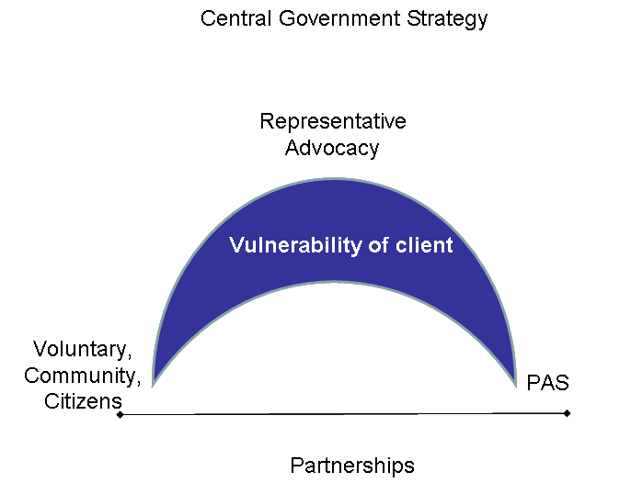
Figure 1: Single Arc providing Advocacy Services to People with Disability
A national service that can truly function as a seamless service for both service users and stakeholders, requires a structure that is capable of responding, adapting and growing as the need changes over time. The national service, those who work in it, those who are served by it and those who support it, require clarity on the services, goals, effective measurement, management of performance and operating conditions that will ensure its success.
The implementation of PAS is critical to the development of a full national advocacy service. Not only has it a function under its legislative provisions, but its presence or absence has consequences for the effectiveness of other advocacy services.
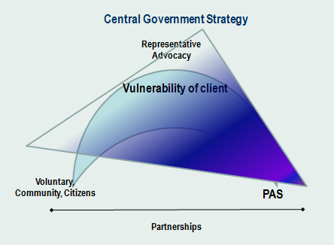
Figure 2: Model of Legislative and Consequential Effect of the implementation of the Personal Advocacy Service

The evaluation team recommends that the following service principles are adopted as a starting point in moving the advocacy service from a project based structure, towards a mature and fit-for-purpose advocacy service beyond 2010.

  - People with Disabilities at the Centre: where people with disabilities will be at the centre of service provision as user, advocate or provider.

  - Professional Development, Professional Delivery: where each staff member, paid or volunteer will achieve a minimum standard of competency in their role, will be assessed on an ongoing basis and will be led by a competent authority in their area to deliver a competent, professional, independent and satisfying service to all service users.

  - One Team, One Service: where advocates will offer a consistent, quality-assured, valued service, nationally, that is accessible to all people with disabilities and actively seeks out those who are most vulnerable regardless of disability type.

  - Work with, Work for: where advocates will actively work to create and develop partnerships between disability organisations, service providers, service users, community and other stakeholders so that all get value from their involvement.

  - Share the Success: where the value of the investment and the benefit that it brings, will be communicated openly while safeguarding confidentiality as determined by the service user.

The evaluation team believes that in adopting these principles, the future advocacy service will address many of the challenges raised regarding the current configuration. Furthermore, in order to effectively and efficiently deliver the required change in a consistent manner with consistent outcomes, the service must be managed through a national structure organised and delivered locally.

A national structure requires a national organisation to be established or identified, that at the very least offers a consistency of approach within which the new advocacy service can be delivered. The national organisation model would be supported and influenced by national and regional advisory groups, similar to what the steering group currently does for each project, but with increased focus on change and action in support of the advocates' work. The national organisation, through its regional remit, would act as the employer and would be governed by a board structure. All services would be delivered locally through regional and local structures.

While several organisations met a number of the criteria, only one stood out as being independently capable of supporting the delivery of the advocacy service nationally, without significant change being required, while also addressing the vast majority of the concerns raised throughout the evaluation. The Citizens Information Service network (CIS), long established, with an existing infrastructure offering information, advice and advocacy services, matched many of the criteria outlined.

The CIS network offers free services to citizens in over 250 locations across the nation, not counting the locations that advocates already operate from, and, with agreement, may continue to do so. This affords a level of mainstream contact not offered by any other organisation. The CIS network with staff, management and boards, representatives of local community and key organisations, represents an existing vehicle to offer advocacy as a service locally and nationally.

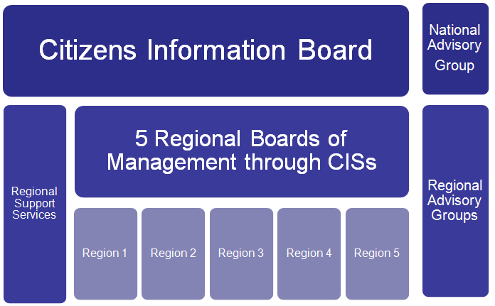
Figure 3: Structure of National Advocacy Organisation
The Citizens Information Board will retain overall responsibility for the Programme, and will seek agreement from five established CIS Boards of Management to take up responsibility for delivering the service locally in each of five regions. A director of PAS to be appointed within the Citizens Information Board and with this appointment, PAS delivery will be managed to ensure its effective use.

Each region will have responsibility for a local advocacy service comprising a team of advocates and an advocacy manager, which will be separate from the CIS information service. They will be team-based and form part of a national team providing advocacy services. They will be advised and partnered by regional and national advisory groups. They may also be supported by local fora as necessary if directed by the Regional Advisory Group. The recommended advisory groups will supplement any shortfall in knowledge, experience or influence that may be required specifically in the area of advocacy for people with disabilities.

In considering the organisational and structural aspects of the future National Advocacy Service the following components should be considered:
- Advocacy operating model
- Governance
- Strategy development and deployment.

Advocacy Operating Model

The basic operating model addresses the needs of service users, the needs of those working in the service and the needs of the stakeholders supporting or funding the service. A team-based approach within each region is proposed, delivering services locally where they are needed. Five regions are proposed.

Regional Team
A regional team led by an advocacy manager and comprising senior advocates, advocates, citizen advocacy co-ordinator and administrator.
The citizen advocacy co-ordinator, advocates, senior advocates and advocacy manager will each satisfy minimum experience and qualification requirements which will be set out as part of ongoing competency development and succession planning. Depending on the position, these will include experience and qualifications in management, disability and advocacy.
In the delivery of PAS, it is envisaged that PAS powers will be devolved to senior advocates in each of the regions for those who are eligible under the legislation and by agreement with the Director of PAS.

Advocacy Support Services and Structures

Throughout their interaction with service users, each advocate will be supported by an advocacy manager, peers, internal/external supervision and a professional network. This model ensures that advocates are no longer isolated; standards are set and maintained through peer support, management structures and professional development.
Advocates will be supported by a number of regional and national support services provided through the Citizens Information Service (CIS) network and the Citizens Information Board. The CIS network will support the advocacy teams with their expertise in information provision, governance and facilities located in selected CIS’s. CIB will provide support in Information Communications Technology (ICT), human resources, financial Services, public relations, communication and promotional work.

Governance

The National Advocacy Service headed up by the Citizens Information Board will be established regionally through selected CISs. It will be managed through existing structures within the Citizens Information Board, through the CIS network and the Citizens Information Board regional management structures.

Governance through one CIS Board for each Region

The board of each selected CIS will take on responsibility for the delivery of advocacy services within a defined region. Each selected CIS board will take on the governance and employer responsibility for the regional advocacy team and these will be integrated with the services already provided by the CIS. Advocacy, however, will remain a dedicated service in its own right with each advocacy manager reporting directly to the CIS board. The CIS board will report on its advocacy service in the same way that it reports on its information, advice and advocacy services.

Regional and National Advisory Groups

Each regional advocacy team and its board will be supported by an advisory group set up to ensure the critical elements of successful advocacy provision are maintained i.e. independence protected, diversity among stakeholders created, service users reached, access achieved, change implemented and value delivered. The advisory groups will be created at both national and regional level. At regional level, they will be inter-linked by having a member of each regional advisory group join each selected CIS board. The five regional advisory groups will be linked to the national advisory group through regional representation.

The National Advocacy Service will require an operating definition of how it will conduct its work; the standards by which to assess outcomes, and a measurement system that will evaluate its success. Key components of this are:
- Reach: to define and establish what constitutes someone who is vulnerable, how they should be identified and reached by the advocacy service and how such service users should be prioritised while maintaining open access.
- Independence: to define and establish the role of independence in the delivery of advocacy so that the service users can be assured that their wishes will be respected and their interests and rights safeguarded.
- Diversity, Collaboration and Partnership: to define and establish how diversity, collaboration and partnership will be maintained within advisory groups and how wider collaborative relationships can be facilitated at local and national level contributing to the richness of services for service users.
- Performance, Efficiency, Effectiveness and Quality: to define and establish how best practice will be maintained to guarantee standards of performance and quality in the delivery of services and how outcomes will be measured to determine the effectiveness of the service.

In moving into its next phase of development, the Citizens Information Board, with responsibility for Citizens Information Service (CIS), will continue to be one of the key support agencies of representative advocacy in Ireland. It is imperative it retain a significant role within this arena. Having a national identity and renewed programme structure will enable it to build on the strength of the pilot programme.

Should the recommendations of this report be implemented, the revised national structure of advocacy will consolidate representative advocacy provision for people with disabilities, ensure a greater reach and the use scarce resources to the optimum.

It is envisaged that the new structures will make better use of the present annual funding, making possible greater equity of provision and supporting the National Disability Strategy and the State’s social policy initiatives. They will also demonstrate how the public service is meeting its obligations to people with disabilities and most importantly, support and empower individuals with disabilities to be heard effectively.

The most commonly occurring disabilities include mobility and dexterity disability (56%); pain (47%), remembering and concentrating (35%) and emotional, psychological and mental health (34%). (CSO 2008)
The Citizens Information Board was formally known as Comhairle. To maintain clarity and consistency, all reference to Comhairle, with the exception of legislation, will be as the Citizens Information Board.

